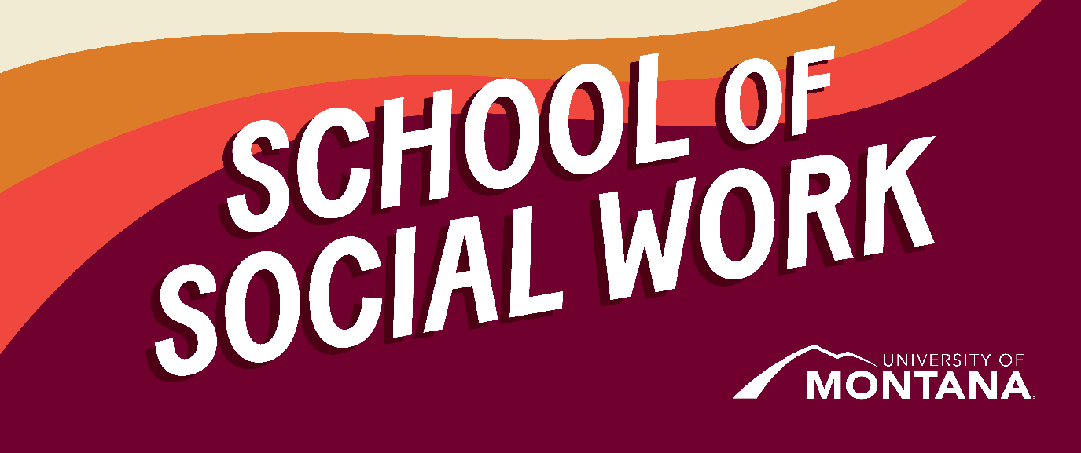
What's Up – A Newsletter from the UM School of Social Work
November is Native American Heritage Month
Montana is home to 12 tribal nations and 7 reservations. Understanding the rich history of Montana’s Indigenous people is critical to social workers seeking to practice in the state. We hope our Native students enjoy this time of reflection on their respective cultures and that non-native students will take the time to learn Native American history related to the land where they reside. Attached to this Newsletter is a document titled “Essential Understandings Regarding Montana Indians,” created by American Indian educators from Montana tribes.
Feeling Overwhelmed? All Social Work Students have access to Wellbeing Coordinators!
Wellbeing Support Coordinators are all MSW students who provide UM students (in person and online) peer support in building resiliency around time management and procrastination, sleep and sleep hygiene, movement, stress, general overwhelm, and assistance connecting to campus resources. We are best utilized in a preventative manner and aim to reach students before crises.
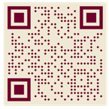
Scan the QR code to book a free virtual or in-person appointment with your Wellbeing Support Coordinator
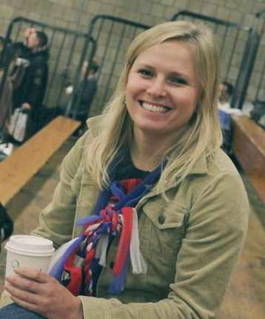
Kate Sholy, First Year MSW Student & UM Wellness Coordinator
Faculty Attend Education Conference
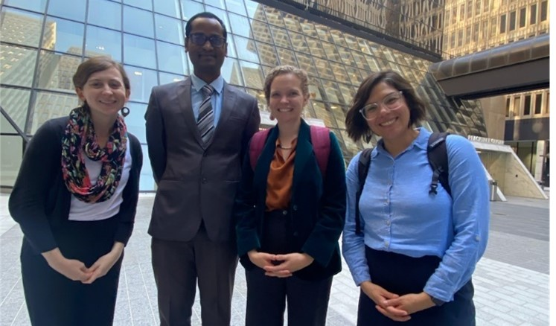
Left to Right: Prof. Kimmie Garner, Prof. Govind Dhaske, Prof. Sarah Reese, Prof. Ashley Trautman
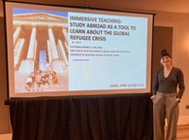
Prof. Kat Werner presenting at CSWE about her immersive teaching course in Germany in May 2023
Interview About CSWE Attendance
Clinical Associate Professor, Deanna Cooper
Question: What was your favorite key learning?
Deanna: I was so inspired by one of the keynote speakers, Dr. Jenny Jones, who shared voter suppression's historical and current impacts. She challenged us as social work educators to get students involved in the history and value of voting and resisting suppression efforts. "We cannot be a-historical…If everyone gave up, I wouldn't be here. You wouldn't be here."
Question: What was your favorite presentation of the conference?
Deanna: The most concrete takeaway was in several presentations that acknowledged how the pandemic and the age of overwhelm had impacted students and how to support them. I feel challenged to adopt specific practices and course designs that support students and foster communication as a key skill in social work.
Crisis in Israel
We at the School of Social Work recognize that the crisis in Israel and Palestine is weighing heavily on our hearts. The images of violence and suffering unfolding in the region represent a humanitarian crisis that is difficult to bear witness to. As social workers, we stand firm in our support of the human right to live safely, with dignity and to have basic needs met. We echo the sentiments put out by the International Federation of Social Workers (IFSW) who hold a position of promoting peace, self-determination and freedom for all people living in the region and support calls “for provision of aid and for discussions that address the roots of the conflict in order to protect Palestinian and Israeli civilians from further escalations of violence.”
As noted by a statement published by the Council on Social Work Education, we extend our deepest support to social workers in Israel and Palestine who are working to establish peace, counter genocide while ensuring the safety, dignity, and well-being of people. Social workers interested in supporting colleagues in the region should contact IFSW. Donations of time or money are needed in the following organizations:
- American Jewish Joint Distribution Committee
- Doctors Without Borders
- Global Empowerment Mission
- International Committee of the Red Cross US (via Geneva)
- Save the Children
- Global Citizen
- Palestine Children's Relief Fund
- UNICEF
- Norwegian Refugee Council
The National Association of Social Workers (NASW), in Washington, DC, is the largest membership organization of professional social workers. It promotes, develops, and protects the practice of social work and social workers. NASW also seeks to enhance the well-being of individuals, families, and communities through its advocacy.
BSW Mentoring - BSW Action Required
Bravo to Heidi Holzer, who has provided academic advising to our BSW students over the past four weeks. Academic advising is crucial to providing individualized pathways to meet students’ academic goals and needs. We thank Heidi for the time and care she puts into her advising sessions.
To enhance student experiences in achieving academic and professional goals, the BSW program has paired students with a faculty mentor of their choice over the past two years.
This November, BSW students are invited to choose or reach out to their existing Faculty Mentors. Social work is about building relationships. Establishing a relationship with a faculty whose area of research or practice aligns with your area of interest can be a crucial support during college… and beyond.
Professional goals that include job references, scholarships, and higher education goals can be formally supported by a faculty mentor who knows you, your strengths, and your professional aspirations.
Next Steps:
- Review the attached Faculty Mentoring “Menu” and choose a mentor. If you have one, reach out to them to schedule a meeting this semester or next.
- Sign up in your core social work classes for your top and second identified mentor. SW 200, SW 350, and SW 400 will be providing sign-ups.
- Drop by our Wednesday and Thursday, November 15 and 16, Open House in JRH 019 for refreshments and to learn more about our Faculty Mentoring program.
Funds Available for SW Students in Hardship
The FAST Fund provides emergency financial assistance to students who may be struggling with the ability to pay for things like rent, internet access, utilities, food, transportation, health, and childcare. Awards are up to $300. If you have an emergency financial need, please go to the UFA FAST Fund website to complete an application. Fast Funds cannot be used for tuition.
Social Work Student Spotlight: Sequoia Gregorich
Kudos to Sequoia Gregorich, a senior BSW student in the in-person MSW program. Sequoia gave a wonderful presentation about the work of her practicum agency, The Montana Innocence Project, at DiverseU on Nov 4th.
Sequoia educated attendees on the prevalence of wrongful conviction and the organization's mission to "free the innocent and unjustly incarcerated and advocate for systems of Justice that are accurate, accountable, and fair for all." The Montana Innocence Project was founded at the UM Alexander Blewett III School of Law in 2008 and has since freed 10 Montanans, some of whom were wrongfully imprisoned for more than 20 years. To learn more about the Montana Innocence Project (especially their amazing merch and binge-worthy podcast), visit mtinnocenceproject.org. Thank you, Sequoia, for your work and for taking the time to educate others!
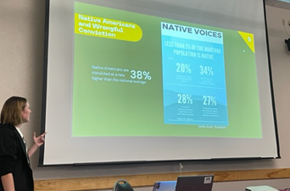
Sequoia Gregorich presenting at DiverseU
You're receiving this update because you're part of the UM School of Social Work community.
University of Montana – School of Social Work • Jeanette Rankin Hall • Missoula, MT

