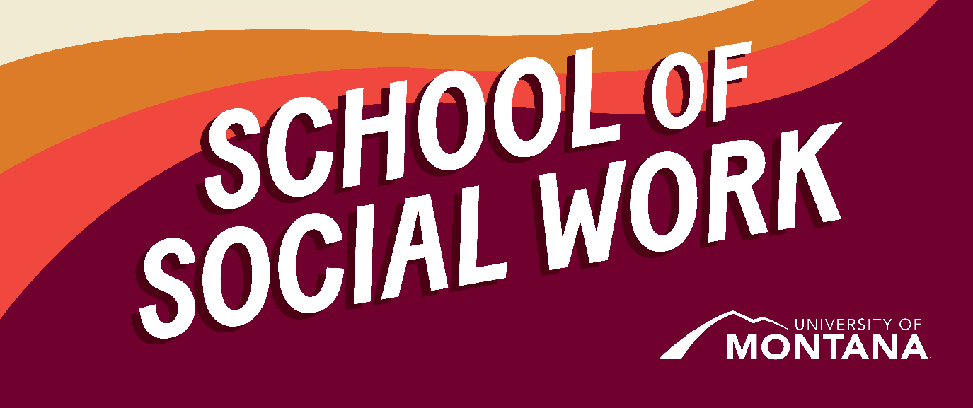
What's Up – A Newsletter from the UM School of Social Work
Election Outcome
By Amanda Cahill and NASW WV
We are sharing this list of post-election resources from WV NASW. Additionally, you are invited to see the statement put out by the NASW regarding presidential election results.
We acknowledge that there are many viewpoints surrounding the election results. We call on you all to be deep listeners in your communities and to keep pushing for care and better policy for vulnerable populations.
From NASW West Virginia:
Post-Election Resources
NASW Statement on Election Results
"...we will challenge any of his policies that harm our nation’s most vulnerable populations."
"As we enter this new presidency, NASW emphasizes the importance of resilience, advocacy, and continued support for social workers nationwide. We urge our members to remain active in shaping policies that affect social work practice and improve well-being of our entire society."

Practicing Self Care and Building Community for Yourself and for Your Clients
- Crisis text line: Text ELECTION to 741741 for support on coping with the election
- How to build a care toolkit for yourself and your community. Indiana University School of Medicine
- Strategies for coping with election stress, from a therapist who runs a group on getting through the presidential election. Seattle Times
- 11 affirmations to help ease election anxiety. Odyssey Online
- Specific tips for managing sociopolitical stress. Lafayette Counseling Center
- Tools for self and community care, including building a positive support network. The Better You Institute
- While we make mental health a priority at the ballot box, we also need to make mental health a priority for ourselves. #Vote4MentalHealth NAMI Campaign
- Election Day and Beyond: Managing Stress. Psychology Today
Tips for Discussing the Election with Clients
- Johnson and Neupert (2023) found that future-oriented tactics, such as anticipatory coping, may play a protective role in managing the physical consequences of election-related stress.
- It is important to support clients in their election stress while maintaining neutrality and empathy. Psychology Today
- Supporting clients during this time may include handling political disagreements and decision fatigue. Tava Health
Working with Marginalized Populations to Cope with an Uncertain Time
Marginalized populations, such as BIPOC communities, the LGBTQIA2S+ community,
immigrants, and others, are currently dealing with a very uncertain future. These population-specific resources are meant to help members of these communities to feel less alone in grappling with any feelings they may have.
- Strategies that therapists are using to help marginalized communities cope with harmful political advertising. Minnpost
- Ideas for LGBTQIA+ youth in coping with intense emotions due to the presidential election. The Trevor Project
- Handling political anxiety as a member of the LGBTQIA+ community. It Gets Better
- Strategies for Black women in protecting their mental health this election season. Self
Hotlines/Warmlines Resource List
- A note about accessing hot/warmlines: internet usage and cell phone logs may be monitored and it is impossible to totally conceal usage information. Most resources that offer both chat and telephone resources recommend calling in if users are concerned their internet traffic may be monitored.
- A note about confidentiality: although many resources say their services are confidential and they will only involve law enforcement or other services upon request, it is important to ask the staff member directly (or investigate the policies on the resource’s website, if available) to understand their specific confidentiality policies.
LGBTQ+ Community
- Trans Lifeline 24/7 - call: 877-565-8860.
- THRIVE Lifeline 24/7 - text: +1-313-662-8209 (supports individuals from all marginalized communities)
- TrevorLifeline, TrevorText, & TrevorChat 24/7 - Text “START” to 678-678 or call 1-866-488-7386 (LGBTQ+ young people ages 13-24)
BIPOC Communities
- BlackLine 24/7 (BIPOC and LGBTQ+ community) - call or text: 1-800-604-5841
- DeQH (The Desi LGBTQ+ Helpline for South Asians) - call: 908-367-3374.
- LGBTQ+ Muslims INARA Warmline - call: 717-864-6272
- THRIVE Lifeline 24/7 - text: +1-313-662-8209 (supports individuals from all marginalized communities)
- The Steve Fund Crisis Textline 24/7 - text “STEVE” to 741-741 (supports young people of color, LGBTQ+ affirming)
General Resources
- The Crisis Text Line 24/7 - text: “HOME” to 741-741 or “ELECTION” to 741-741 for specific election related coping support
- 988 Suicide & Crisis Lifeline 24/7 - call, text, or chat 988.
- National Alliance on Mental Illness (NAMI) HelpLine - Call 800-950-6264, text "helpline" to 62640, or chat online.
- Veterans Crisis Line - Call 988, then press 1; text 838255; or chat online.
- SAMHSA's National Helpline - Call 800-662-HELP (800-662-4357)
- Teen Line - Call 800-852-8336 (youth in need of support)
UMSSW Faculty at the Council on Social Work Education Annual Program Meeting
A group of UMSSW faculty traveled to Kansas City this past month to attend the annual program meeting (APM) hosted by the Council on Social Work Education (CSWE). APM is an opportunity to meet, network with, and learn from thousands of other social workers and social work educators about best practices in pedagogy, research, and field education.
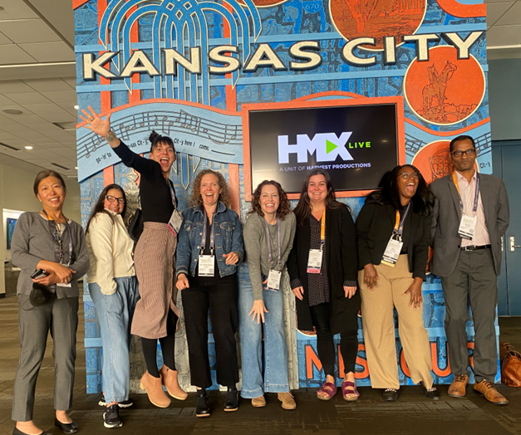
(Left to right: Dr. Phyllis Ngai, Dr. Co Carew, Prof. Kat Werner, Dr. Sarah Reese, Prof. Jen Barile, Prof. Sarah Fielding, Prof. Deja Williams, and Dr. Govind Dhaske)
Several UMSSW faculty also presented at the conference. Dr. Phyllis Ngai is working with CSWE Council of Global Learning and Practice on developing a curriculum guide. Phyllis presented to the Council the curriculum framework that she developed. This will serve as the guiding framework for schools of social work around the U.S. to prepare social workers to address the interconnections of local and global justice issues.
Deanna Cooper and Kat Werner discussed ethical dilemmas and social justice implications of online programming exploring how administrators and educators create meaningful dialogue about program development and implementation rooted in our profession’s social justice values and how we work through the ethical dilemmas of university-based programming versus for-profit education models.
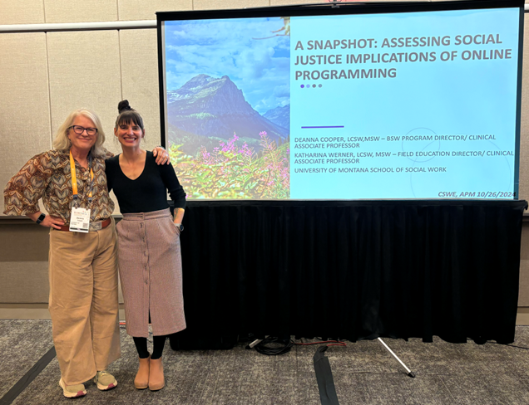
(Left to right: Prof. Deanna Cooper & Prof. Kat Werner)
BSW Student Spotlight
Sophie Trudgeon, helps voting efforts with practicum at MT Women Vote
I'm completing my BSW practicum at Montana Women Vote, a nonpartisan 501c(3) nonprofit that works to engage low-income individuals in the political process. With the 2024 election and the 2025 Montana legislative session approaching, my placement provides me with unique opportunities to observe and engage in these spaces. I am excited to continue exploring various avenues for social workers to get involved in policymaking and advocacy on a macro level.
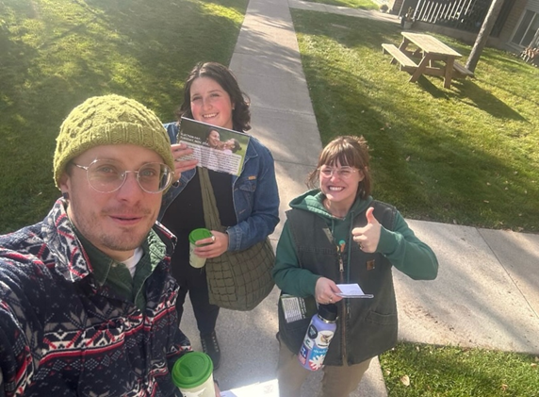
Restorative Justice
By Dr. Jen Molloy
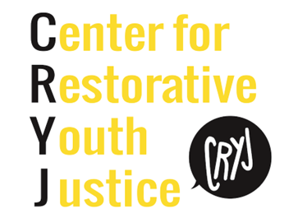
The Center for Restorative Youth Justice (CRYJ) is known around the state of Montana for the impactful work it does with teens, families, justice agencies, and school discipline teams to reduce youth involvement with the legal system, interrupt cycles of harm, repair trust, promote accountability and foster connections in the Flathead Valley. Learn more about the impactful work CRYJ does to create opportunities for reflection, connection, and empowerment of teens, victims, and families here.
CRYJ will be opening a Missoula office this summer!
CRYJ has had practicum students at their Flathead location and will soon be offering BSW and MSW placements at their Missoula location. Stay tuned for more information.
To learn more about restorative justice in Missoula reach out to jen.molloy@umontana.edu.
Grassroots to Global: The Power of Public Health
By Dr. Phyllis Ngai
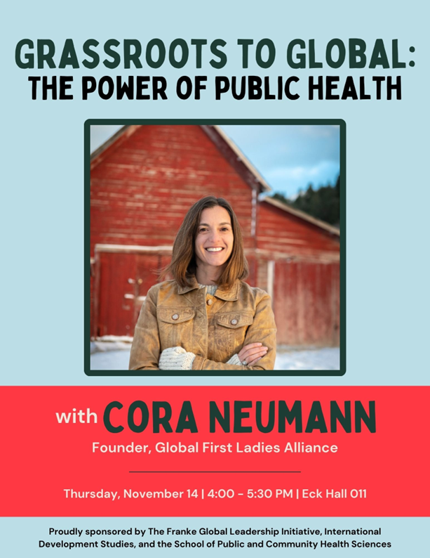

What: “Grassroots to Global: The Power of Public Health”
Who: Cora Newman, Founder, Global First Ladies Alliance
When: Thursday, November 14
What time: 4:00-5:30 p.m.
Where: Eck 011
More info (Griz Hub): https://umt.campuslabs.com/engage/event/10671994
Cora has over twenty years of experience in the public, private, and non-profit sectors, including working at the U.S. State Department, the RAND Corporation, the Montana Public Health Institute, the Bush Institute, Care(dot)com, and the World Health Organization. She currently serves as Chief Community Health Officer for the Native American Development Corporation. Throughout her career, she has designed strategies and brought together local, Tribal and national leaders to deliver quality, accessible health care and social services to underserved communities. In 2009, Cora launched the Global First Ladies Alliance in partnership with the offices of First Ladies Laura Bush and Michelle Obama and has worked with more than 70 first ladies around the world to support their delivery of critical social services to their populations.
Cora brings her sense of public service to her professional life, including serving on the board of Columbia University School of Public Health, Nitsiniikookit - a storytelling non-profit led by award-winning Blackfeet filmmakers Ivan and Ivy MacDonald, serving as a former regional Vice President of the Montana Public Health Association, and she is currently running for public office. Cora has a master’s degree in public health from Columbia University and doctorate in public health and development from the University of Oxford (topic: revitalization of Indigenous knowledge for public health). Cora grew up and is based in Bozeman, Montana surrounded by four generations of family, from her grandmother to her two children.
You're receiving this update because you're part of the UM School of Social Work community.
University of Montana – School of Social Work • Jeanette Rankin Hall • Missoula, MT

