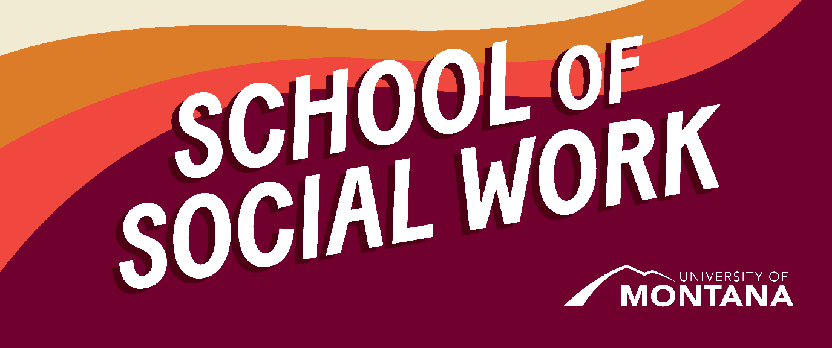
What's Up – A Newsletter from the UM School of Social Work
Faculty and Staff Attend Council on Social Work Education Conference (CSWE) – Denver, Colorado
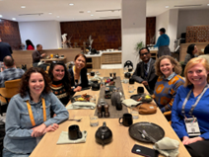
Left up to right down: Jen Barile, Kinsey Webb, Phyllis Ngai, Govind Dhaske, Sarah Reese, Hannah Knipp. At breakfast, enjoying good conversation and company at CSWE.
Several faculty members from the School of Social Work recently attended the 2025 CSWE Annual Program Meeting, bringing back fresh insights on emerging trends in social work education. Their participation allowed them to engage with national leaders on best practices in teaching, field education, and integrated practice. Faculty are already incorporating new ideas—ranging from updated policy content to innovative classroom strategies—into their courses. Students will directly benefit through strengthened curricula, deeper community-based learning opportunities, and a more forward-looking approach to social work practice.
UM Faculty David Kilmnick Recognized as one of Long Island’s Top 100 Influencers!
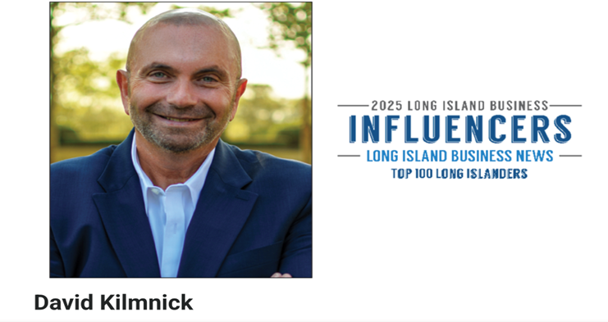
UM’s Clinical Assistant Professor, David Kilmnick is a nationally recognized LGBT advocate and nonprofit leader, best known for founding and expanding the New York LGBT Network into a major organization serving thousands. He has led groundbreaking initiatives in community centers, senior housing, and economic inclusion, and his work includes national and international advocacy efforts. Congratulations to David on this accomplishment! See the full article here.
2+2 Welcomes Hailey Michelson to the Team!
The 2+2 program welcomes Hailey Michelson as a Distance Education Support Specialist. Hailey is a recent graduate of the MSW program and is excited to begin her new role supporting distance BSW students in their academic journeys. Hailey has begun traveling across the state to visit with BSW students and partnering colleges. Thus far, conversations have been about how to build belonging and create community despite the distance between students. If you have ideas about this, please reach out to Hailey and share them!
A Message from the Social Work Student Advisory Council (SAC)
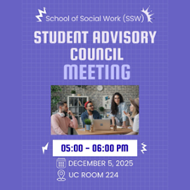
The SAC has been busy this semester! On December 5th they will host their third and final meeting of the fall semester. Please consider joining in-person (UC224) or online (https://umontana.zoom.us/j/3420294593) to learn more about the SAC and contribute to outlining shared values that will guide the work moving forward.
Why participate in the SAC? It’s an opportunity to:
- Collaborate with faculty and peers to shape student-centered initiatives
- Gain experience in group facilitation and inclusive decision-making
- Create a more transparent and responsive academic environment
- Uplift diverse perspectives and promote equity
- Be part of a legacy of student leadership and advocacy!
A Message from the Chair
By Sarah Reese
This is a busy time of year! As the semester is coming to a close, I am aware of the stress that often puts on students. You may or may not know that The University of Montana has Wellbeing Support Coaches that are available to all students – both in person and online. Booking with a coach is simple and they can connect you with other services. In addition to this resource, please reach out to staff and faculty for support. I’m also available - please join me for “Chats with the Chair,” an informal opportunity to get to know each other and hear what is most important to you.
Zoom Link: https://umontana.zoom.us/j/3246116459
- Friday, December 12 12:00-1:00 MT
- Friday, January 9 12:00-1:00 MT
- Friday, February 13 12:00-1:00 MT
- Friday, March 13 12:00-1:00 MT
- Friday, April 17 12:00-1:00 MT
Environmental Justice Elective
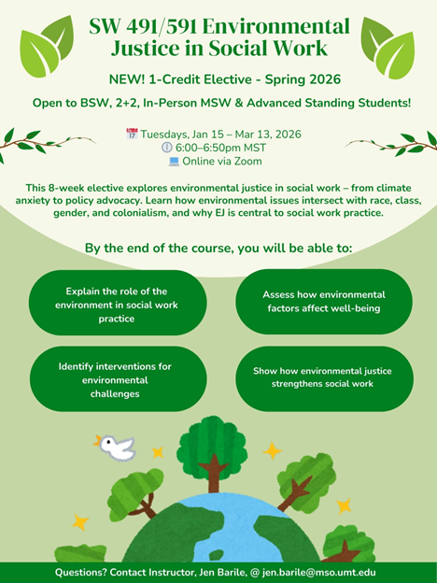
New Elective: Environmental Justice in Social Work (SW 491/591)
Instructor: Jen Barile, MSW
Offered: Spring 2026 | Tuesdays, 6:00–6:50 PM MST | Online via Zoom
Credits: 1
Open to: BSW, 2+2, In-Person MSW, and Advanced Standing Students (Not currently open to Online MSW students- but coming this Summer!)
Dates: January 15 – March 13, 2026
This 8-week elective invites students to explore how environmental justice intersects with race, class, gender, and colonialism and why it’s central to ethical, effective social work. From climate anxiety and trauma-informed care to policy advocacy and Indigenous resistance, we’ll examine how environmental issues shape the lives of our clients, our communities, and our profession.
Whether you’re drawn to clinical work, community organizing, or systems change, this course offers tools and frameworks to support people and places facing environmental harm.
Learning outcomes include:
- Explaining the role of environmental justice in social work
- Assessing environmental impacts on human well-being
- Identifying interventions for environmental challenges
- Understanding how EJ strengthens social work practice
Questions? Contact Jen Barile at jen.barile@mso.umt.edu
UM Social Work Students Present at DiverseU on Global Migration, Refugee Resettlement, and Belonging
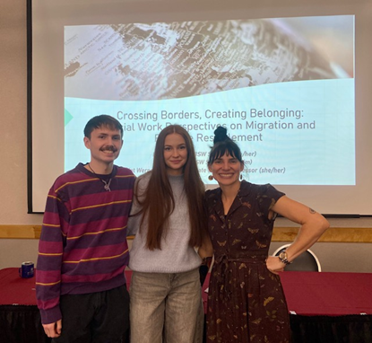
Associate Clinical Professor Kat Werner and BSW students Riley Hickey and Mae Anderson presented their session “Crossing Borders, Creating Belonging: Social Work Perspectives on Migration and Refugee Resettlement” at the University of Montana’s 20th Annual DiverseU conference held in November.
Their presentation drew from experiences in the immersive study abroad course in Berlin, Germany “Social Justice & Integration: German Perspectives on Refugee Resettlement”, offered biannually through the UM School of Social Work. The course includes on-the-ground engagement with German and EU policymakers, frontline social workers, NGOs, and historical sites to explore migration, democracy, populism, and belonging through a transnational lens.
During the session, Riley and Mae invited participants to reflect on their own histories of movement, consider the meaning of home and community, and draw connections between the European refugee context and current debates on immigration in the U.S.
The Berlin study abroad course is offered every other spring and is planned to run again in Spring 2027. Students interested in global social work, migration, refugee issues, or immersive learning opportunities are encouraged to reach out to Kat katharina.werner@umontana.edu for more information.
Submit Your Poem to the National Poetry Contest for Social Workers 2026

The University of Iowa School of Social Work conducts an annual, nationwide poetry contest to acknowledge the creative talent of social workers and to draw attention to social work as a profession. Social work students from an accredited social work program are eligible to participate and there is no cost to enter the contest. Find out more here.
Deadline for submission is Saturday, January 31, 2026, by 11:59 p.m. (Central Time).
You're receiving this update because you're part of the UM School of Social Work community.
University of Montana – School of Social Work • Jeanette Rankin Hall • Missoula, MT

