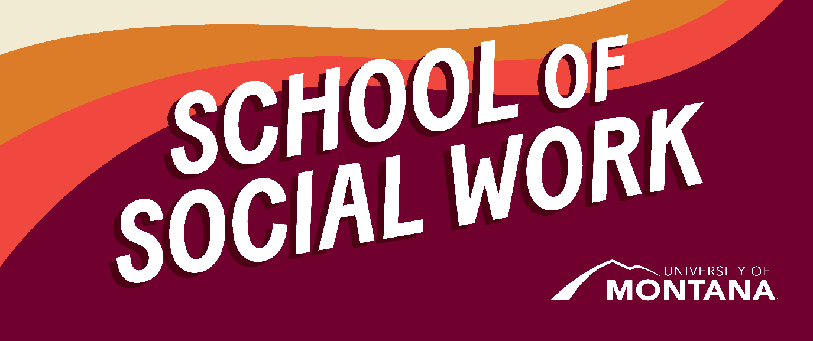
What's Up – A Newsletter from the UM School of Social Work
Presidential Lecture Series features Dr. Robin Wall Kimmerer
Dr. Robin Wall Kimmerer is a mother, scientist, decorated professor, and enrolled member of the Citizen Potawatomi Nation. A MacArthur Fellow and founder and director of the Center for Native Peoples and the Environment, she is the author of Braiding Sweetgrass: Indigenous Wisdom, Scientific Knowledge and the Teachings of Plants, earning Kimmerer wide acclaim. Braiding Sweetgrass was the MSW In-Person Summer read. This event is free, open to the public, and available in person and on Zoom—October 10th at 7 pm MST. Please visit the President's Lecture Series for more information.
Indigenous People's Consortium | An Alaska Native Integrated Lifecycle Approach to Understanding Alzheimer's Disease
Please join the Geriatric Workforce Enhancement Program (GWEP) and Indigenous People's Consortium in October as Dr. Rosellen Rosich, Dr. Maria Crouch, and Steven Harris present: "An Alaska Native Integrated Lifecycle Approach to Understanding Alzheimer's Disease" on October 19th at 3:00 pm MST. Please Register to attend via Zoom.
NASW Conference
Montana and Wyoming are once again excited to host a virtual conference open to all behavioral health professionals. This event will consist of 15 CEUS and be completely virtual, providing an accessible learning space for urban and rural participants. We look forward to announcing our speakers soon and enjoying two full days of critical learning from various presenters. Please visit the NASW MT Chapter for more information.
A Court Win for the Trans Community in Montana!
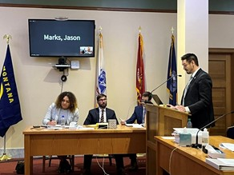
From the Missoula Current: On Sept 27th, a Missoula County District Court judge granted plaintiffs’ request for a preliminary injunction against Senate Bill 99, which made it illegal for young people who are transgender to receive gender-affirming care. Access Missoula Current to read the full article.
Shout out to our UM BSW Club for attending the rally at the Court House to support Trans rights in Montana!
New Faculty! The School of Social Work is growing,
and we are excited to introduce 3 new faculty members:
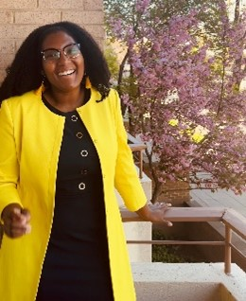
Deja Williams
Introducing Deja Williams, JD/MSW
Hello! My name is Deja Williams. I am a Clinical Assistant Professor in the School of Social Work.
Here’s a little bit about me: I recently graduated from George Washington University School of Law in May 2023. Before submitting myself for torture…I mean, going to law school. I received my BSW from Spring Arbor University and MSW from The University of Michigan. My areas of concentration were interpersonal practice and mental health. I started my career at Michigan Medicine in the Adult Inpatient Psychiatric Unit. I then transitioned to a community mental health non-profit where I worked as a Multi-Systemic Therapist serving court-involved youth charged with delinquency and at risk of removal for placement in detention, rehabilitation, or foster care. It was through this work that I decided to go to law school. I engaged in many kinds of social work-related legal services during law school. I clerked for the Supreme Court of Michigan. I served with a non–profit organization as a Human Trafficking Law Fellow. I worked for a law firm that developed and preserved multifamily affordable housing for communities across the nation, and I served in a healthcare law clinic as a Student Attorney, where I represented real clients who received Medicare, Medicaid, and other SNAP Benefits in claims against the government for wrongful termination of benefits and other related issues.
I am so excited to join this community! I would have never, in a million years, thought I would be so passionate and invested in teaching the intricacies of law and social work, social justice, and healthcare. Your career is a journey. It’s a roller coaster, and I am so excited to be on it with you!
Introducing Dr. Govind Dhaske, Ph.D., MSW
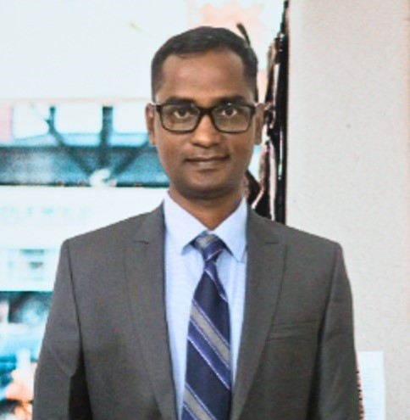
Dr. Govind Dhaske
Dr. Govind Dhaske is a highly skilled and accomplished professional in the field of social work with experience within generalist, clinical, and medical realms. With over 15 years of experience in a multitude of verticals in human development, Dr. Dhaske has made significant contributions to research, execution, management, impact analysis, strategic advocacy, and corporate social responsibility focused on gender, health, sustainability, and social and economic justice. As a social work educator, Dr. Govind has been engaged in the topics that broadly fall under social work research, policy, pedagogy, and practice.
On the service front, Dr. Dhaske has been a mentor, advisor, and motivator serving first-generation students from historically marginalized backgrounds. Through an initiative launched by his social work students (an organization named Eklavya), he has been promoting ethical community scholars and leaders, further advancing anti-caste and anti-racist ideals in social work and other disciplines. Some of his students have received scholarships, such as the Chevening, and gone on to study at prestigious universities in Europe and North America.
As an activist scholar on harmful cultural practices surrounding the matting of hair, Dr. Dhaske is known as a unique, knowledgeable expert who unravels hair symbolism, stigma, discrimination, and sexuality surrounding hair. His evidence-based advocacy showcases his passion for social and gender justice and his commitment to promoting positive change in communities around the world.
Dr. Dhaske has contributed extensively toward impact studies of development projects for nonprofits and CSR initiatives through innovative methodologies. Dr. Govind has published several peer-reviewed papers, articles, book chapters, and books in the fields of social work, gender studies, public health, sociology, political theory, and cultural anthropology.
Introducing Kimmie Garner, MSW
Hello! My name is Kimmie Garner. I am originally from the South (Georgia and North Carolina) and reside in Carrboro, NC. I graduated from the University of Montana School of Social Work with my MSW in 2015.
Since graduating, I have lived in New Mexico and North Carolina, engaging in social work practice at a federally qualified health center serving primarily Spanish-speaking patients, a rural local health department implementing a statewide maternal and child health grant, and supporting faculty and students in community-engaged courses through Duke University's Service-Learning Program. I have also been part of MSW Field Education through roles as a Field Instructor at Duke University's Center for Truth, Racial Healing, and Transformation and served as an Outside MSW Supervisor with the University of Montana's Online MSW Program during the 2022-23 academic year. In addition to my Field Liaison role, I work part-time on the National Maternal Mental Health Hotline, serving help seekers in both English and Spanish, and am accruing hours towards my LCSW. I also have training as a birth doula, am a Certified Lactation Counselor, and have my certificate in Teaching English to Speakers of Other Languages (TESOL).
I live in Carrboro, NC, with my husband, Sam, and our nearly 3-year-old daughter, Daphne. We got engaged in Missoula at the Big Dipper in 2017, so it holds a special place in our hearts! We've lived in New York, Montana, New Mexico, and North Carolina and enjoy traveling domestically and abroad.
I look forward to connecting with everyone virtually and during in-person visits to Missoula!
Handbooks
Below is the link to the policy handbook for each respective program. Please review these and download/save yours as a resource.
- BSW Handbook
- MSW In-Person Handbook
- MSW Online Handbook
As always, thank you for trusting UM with your social work education. We are honored to be on this journey with you.
You're receiving this update because you're part of the UM School of Social Work community.
University of Montana – School of Social Work • Jeanette Rankin Hall • Missoula, MT

