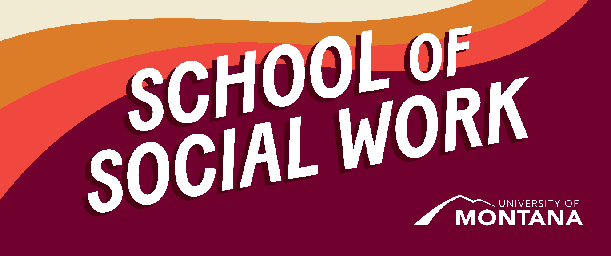
What's Up – A Newsletter from the UM School of Social Work
NASW Montana and Wyoming Annual Conference
Conference Overview
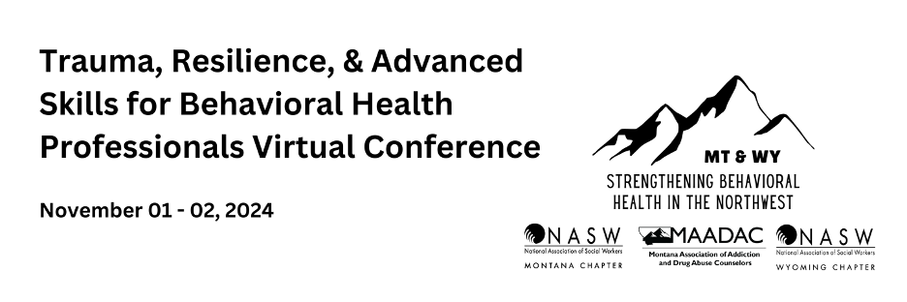
NASW Montana and Wyoming along with the Montana Association of Addiction and Drug Abuse Counselors are excited to host a virtual conference open to any and all behavioral health professionals. This event will consist of 12 CEUs and will be completely virtual providing an accessible learning space for urban and rural participants.
BSW Advising
By Heidi Holzer
BSW advising for Spring 2025 is currently taking place through November 8th. If you have not already signed up for a meeting with Heidi, please reach out to her via email.
Student Wellness
By Kat Werner
As the semester progresses and the holiday season is inching closer, many people feel increased stress. Review the attached wellness newsletter for tips and resources.
A Newsletter Article About a Newsletter!
By Katie Karas
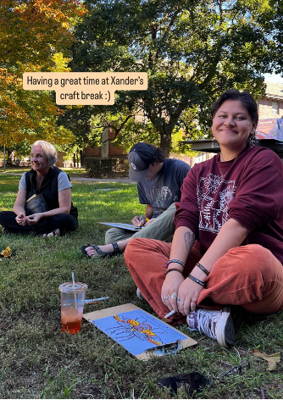
Pictured: Alexander and other MontPIRG members at the "Craft Break" on September 26th, as featured on the MontPIRG Instagram story @montpirg
Alexander (Xander) Tohee (he/they) is a sophomore at UM who opted to complete an internship with MontPIRG this semester. MontPIRG is a nonpartisan, student-led Public Interest Research Group on campus. After his friend was an intern in the spring and focused his project on cleaning up Smurfit Stone, Xander was sold. The organization focuses on civic action and empowering young leaders--and seeing as social work and social justice go hand in hand, Xander was excited to take part in such an important learning experience. As part of his internship, he has co-created a newsletter called The Whimsical Realist, which focuses on the "unintentional disengagement of individuals due to burnout." This newsletter, which came out with its first issue on September 24th, will include content related to current events, burnout prevention and intervention tools, and advertisements for upcoming events in Missoula and on campus. If you're curious to learn more about what Alexander and his colleagues are working on and thinking about, you can sign up using this Google form.
Financial Aid Crisis
By Ashley Trautman
We want to continue to acknowledge and support students who have been affected by the delays in financial aid disbursements. Last Friday a group of students came together to discuss strategies and resources they are using to get through the challenges posed by the financial aid delay. Below is a list of resources they generated. In addition, students decided to create a Mutual Aid email list where interested students can opt in to share strategies, resources and needs. If you would like to join the Mutual Aid list, please fill out this Qualtrics survey. I will send this along to the student organizers. We recognize that some of the resources listed are Missoula specific. We hope that students outside of Missoula will also review this list for potential service ideas in your home communities. Please reach out if you need help researching options.
Resources:
- UM Bear Necessities - Student Support (Local Only)
Food Resources:
- Missoula Food Bank - Alternative Food Resources
  - Missoula Food Bank can also help with completing applications for SNAP
- UM Food Pantry
Cash Assistance:
- Financial aid advances: To be eligible for an advance students must have completed all required loan counseling and credit checks. If a student is interested in this path, please contact ashley.trautman@mso.umt.edu
- UM Emergency Student Support Fund
- FAST Fund– students can apply for money, typically between $100 -$300 for a one -time emergency need. Funds cannot be used to pay tuition or books.
- ASUM Hardship Fund
Financial Aid Advances for Native Students:
- Dr. Karla Bird, Tribal Outreach Specialist, karla.bird@mso.umt.edu, 406-243-5840, in addition Ashley Trautman can provide support.
- Laura Bird with the Financial Aid office may also be a support: 406-243-5373
- American Indian Gateway - Resources
Mental Health and Medical Support:
- Wellbeing Support Coordinators help students work through stress and challenges
- FindHelp.org - Find free or reduced-cost resources like food, housing, financial assistance, health care, and more (nation-wide).
- UM Curry Health Center - Insurance - Medicaid
- Partnership Health Center - Financial Assistance for medical care
- River Rock Crisis Center
- Call 988- Montana’s Suicide and Crisis Lifeline
Rental Assistance:
- ASUM Legal Services – includes housing issues
- Missoula Tenants Union
- Montana Low Income Home Energy Assistance Program
- Hope Rescue Mission Church- Rental Assistance (549-HOPE)
- Human Resource Council (call 211)
You're receiving this update because you're part of the UM School of Social Work community.
University of Montana – School of Social Work • Jeanette Rankin Hall • Missoula, MT

