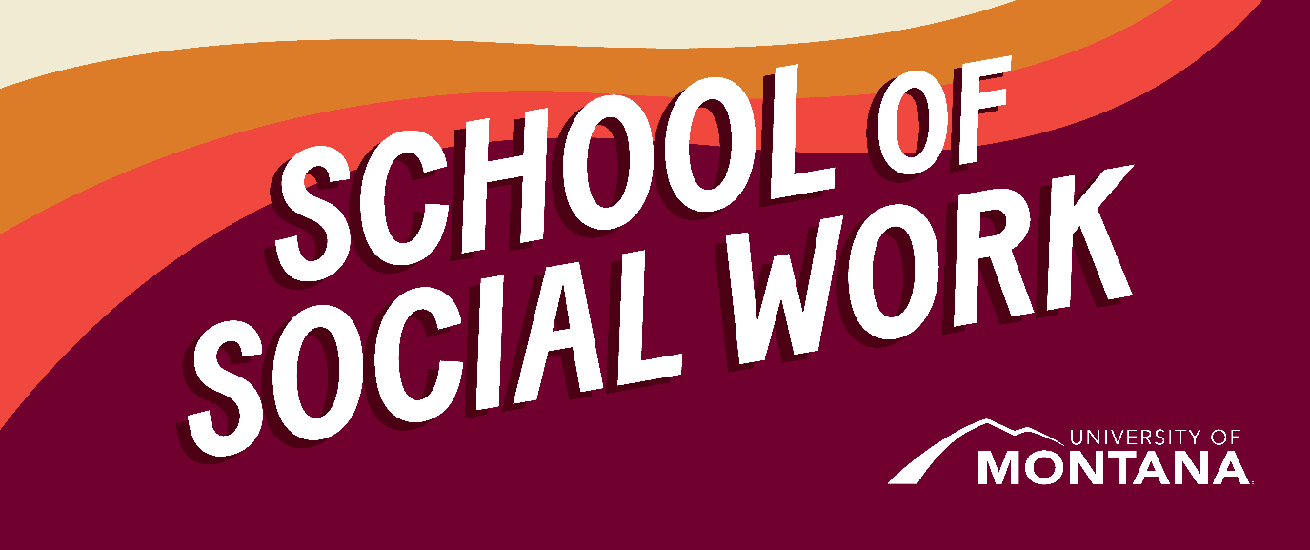
What's Up – A Newsletter from the UM School of Social Work
A Message from the Chair
Hello,
It's feeling like fall in Missoula! The leaves are changing colors, there's a chill in the air, and the heat has been turned on in Jeanette Rankin Hall. As the days get shorter here, I found myself becoming more thoughtful and reflective. I have been reflecting on the role of the university and our school of social work in supporting students. These conversations have led us back to the importance of student engagement and student voice, and I am committed to building systems in our school to better honor students' experiences and needs.
To that end – I want to extend a huge thanks to the following students who are currently serving on the Student Evaluation Committee alongside Dr. Co Carew. You are serving a crucial role in the faculty evaluation process by centering student voice through evaluations. I also want to thank those of you who attended the Student Advisory Council meeting led by School of Social Work Graduate Assistants. Please be on the lookout for more opportunities for this group. Finally, please join me on Zoom for monthly "Chats with the Chair" during the following days and times. This is an opportunity to connect with me, introduce yourself and bring your ideas and concerns. Please always feel free to reach out by email or stop by my office in Jeanette Rankin Hall Room 004.
Zoom: https://umontana.zoom.us/j/3246116459
- Friday, November 14 12:00–1:00 MT
- Friday, December 12 12:00–1:00 MT
- Friday, January 9 12:00–1:00 MT
- Friday, February 13 12:00–1:00 MT
- Friday, March 13 12:00–1:00 MT
- Friday, April 17 12:00–1:00 MT

Take care!
Sarah Reese, PhD, LCSW
Chair & Associate Professor
School of Social Work
Spring 2025 Elective: Social Work and Environmental Justice (SW 492)
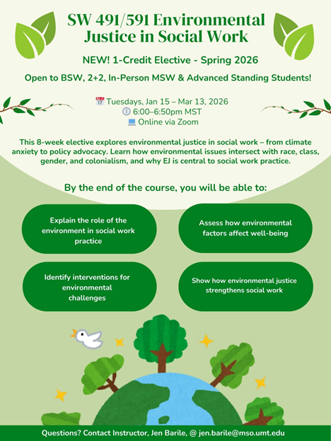
New Elective: Environmental Justice in Social Work (SW 491/591)
Instructor: Jen Barile, MSW
Offered: Spring 2026 | Tuesdays, 6:00–6:50 PM MST | Online via Zoom
Credits: 1
Open to: BSW, 2+2, In-Person MSW, and Advanced Standing Students (Not currently open to Online MSW students- but coming this Summer!)
Dates: January 15 – March 13, 2026
This 8-week elective invites students to explore how environmental justice intersects with race, class, gender, and colonialism and why it’s central to ethical, effective social work. From climate anxiety and trauma-informed care to policy advocacy and Indigenous resistance, we’ll examine how environmental issues shape the lives of our clients, our communities, and our profession.
Whether you’re drawn to clinical work, community organizing, or systems change, this course offers tools and frameworks to support people and places facing environmental harm.
Learning outcomes include:
- Explaining the role of environmental justice in social work
- Assessing environmental impacts on human well-being
- Identifying interventions for environmental challenges
- Understanding how EJ strengthens social work practice
Questions? Contact Jen Barile at jen.barile@mso.umt.edu
SSW Faculty Article Published in the International Journal of Childbirth
Dr. Jessica Liddell, Associate Professor, Kimmie Garner, Clinical Assistant Professor, and Tess Carlson, a Ph.D. candidate in Community and Public Health, co-authored an article titled "Exploring the role of doulas in supporting people with perinatal mood and anxiety disorders." that has been published in the International Journal of Childbirth. Given the prevalence of perinatal mood and anxiety disorders (PMADs) in the United States and the unique role doulas play in the perinatal period as continuous physical, emotional, educational, advocacy, and postpartum support, this article explored possibilities for doulas identifying PMADs and referring clients to relevant mental health and community resources. Findings and themes from 33 semi structured qualitative interviews with participants in Montana who identified as doulas, perinatal people with lived PMAD experience, and maternal and mental health providers are described. The article provides recommendations for continued bolstering of the doula workforce and enhanced access to PMAD training opportunities.
Liddell, J.L., Garner, K.B., & Carlson, T.A. (2025). Exploring the role of doulas in supporting people with perinatal mood and anxiety disorders. International Journal of Childbirth , 15(2), 82–100. DOI: 10.1891/IJC-2025-0002
If you have questions about the research study or the article, you can email Kimmie Garner at kimberly.garner@mso.umt.edu
SSW Faculty Awarded National Grant for Integrating Global Indigenous Voices into Social Work Classrooms
By Phyllis Ngai
CSWE's Kendall Institute awarded Dr. Phyllis Ngai (Project Lead), Dr. Co Carew, and Dr. Jessica Lidell (Co-Leads) a competitive grant to create an online resource hub that will house and disseminate teaching/learning materials that elevate the voices of Indigenous peoples living in different contexts around the world. The resource hub will be a product of collaboration among a virtual network of educators and community partners recruited nationally and internationally. Project participants will contribute teaching/learning materials in the form of videos, audio recordings, or visual representations of artistic expressions that they curate, create, and/or co-create with Indigenous collaborators and allies in their local contexts. The online hub will also serve as a transnational virtual space that generates solidarity among Indigenous participants and allies in support of demarginalizing Indigenous voices of strength, resilience, and well-being.
Faculty members and students: You and your Indigenous community partners in Montana or anywhere in the world are invited to join this project. If you are interested in co-creating with us, please reach out to Phyllis, Co, or Jessica. Email: phyllis.ngai@umontana.edu
Dr. David Kilmnick Unveils Bold New Vision at NY LGBT Network Event
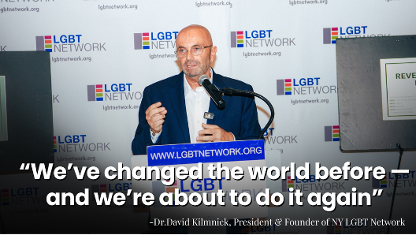
Dr. David Kilmnick, Clinical Assistant Professor in the Online MSW Program, recently delivered keynote remarks at the NY LGBT Network's "Reveal + Re/Define" event on Long Island. The event marked a historic moment for the Network, unveiling its new name, logo, and tagline: Thriving Together
Dr. Kilmnick, who founded the organization 32 years ago as part of his MSW project, reflected on its history of creating safe spaces, advancing justice, and building community for LGBTQ+ people. His remarks emphasized resilience and leadership in a time of escalating threats, from school boards restricting trans students' rights to the Supreme Court's rollback of protections such as conversion therapy bans.
"This was not just a celebration of a rebrand," Dr. Kilmnick shared. "It was a reaffirmation of who we are – and a declaration of where we are going, together. We've changed the world before, and we're about to do it again."
The Reveal + Re/Define event drew more than 125 attendees, including community members, advocates, and allies, who witnessed the unveiling of the Network's bold new identity. The moment underscored the organization's renewed commitment to help LGBTQ+ people and communities not just survive, but thrive.
You can watch Dr. Kilmnick's complete remarks on YouTube: https://www.youtube.com/watch?v=LTbnUho9AFc
In addition to his faculty role in the University of Montana School of Social Work, Dr. Kilmnick continues to serve as President of the NY LGBT Network, where he integrates his teaching, scholarship, and practice to inspire the next generation of social workers and leaders.
SSW Faculty discussed research and practice on substance use disorder podcast
In this episode of Let's Talk About Drugs in the Intermountain West , we sit down with Dr. Sarah Reese from the University of Montana to explore how Montana's vast landscapes shape the close-knit communities within them. Dr. Reese shares how these deep roots influence her approach to social work, especially when supporting children and families affected by perinatal substance use disorder. Through the lens of Community-Based Participatory Research, she highlights how trust, connection, and collaboration are key to creating meaningful, lasting change.
Listen to Dr. Sarah Reese's podcast interview titled Episode 63: Big Sky, Deep Roots
You're receiving this update because you're part of the UM School of Social Work community.
University of Montana – School of Social Work • Jeanette Rankin Hall • Missoula, MT

