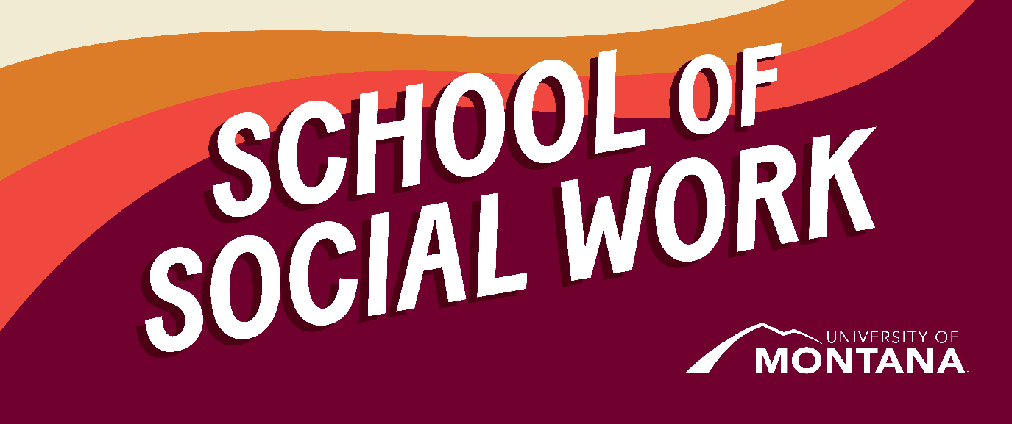
What's Up – A Newsletter from the UM School of Social Work
Reminders
Please remember these helpful UM resources as you embark on another year of learning. These are all available to help you in your coursework:
- The Writing Center: This is a NO-COST service available to all students. Everyone can benefit from working with the Writing Center, even if you’ve been told you’re a strong writer.
  - How it works: Book an appointment with a consultant and discuss your paper/project. From there, you and your tutor will map out a plan to address your needs and writing concerns.
  - Access the following link to learn more: Writing Center
- The Mansfield Library: The UM Library offers free access to thousands of journals, articles, and databases. The Onesearch tool makes it incredibly easy to research any subject and find credible sources.
News
Indian Child Welfare Act Upheld
On June 15, 2023, the United States Supreme Court handed down its decision in Haaland v. Brackeen and, in a 7-2 opinion, resoundingly affirmed the constitutionality of the Indian Child Welfare Act (Native American Rights Fund, 2023)
Read more about this important news here!
Judge Rules in Favor of Montana Youths in a Landmark Climate Case
The court found that young people have a constitutional right to a healthful environment and that the state must consider potential climate damage when approving projects (New York Times, 2023). Read the full article here (note: if you get firewalled/asked to subscribe, you can access this through the Mansfield Library resources- search key terms in Onesearch).
September is National Suicide Awareness Month
Social workers play a key role in suicide prevention and awareness. Take time this month to learn more about this issue. Below is one event, but more are happening all around the country and online. NAMI is an excellent resource.
STAY

"Speaking Out Against Suicide”
Sept 5, 2023 (6:30 P.M.)
Missoula Public Library
NAMI Missoula
406-880-1013 namimissoula@gmail.com
For more information about a NAMI Chapter near you, please visit: https://www.nami.org/Home
UM School of Social Work Goes Global!
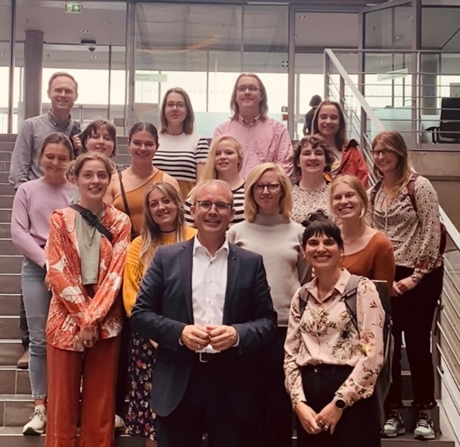
UMSSW Students and Professors Meeting with a Member of the German Parliament
Director of Field Education Kat Werner and Adjunct Assistant Professor Zak Reimer led a study abroad course this spring and traveled to Berlin, Germany, with 13 mostly BSW and MSW students. The 2-weeks immersive experience focused on immigration and refugee resettlement in Europe and Germany's response to the ongoing humanitarian crisis and its support and integration efforts of displaced people. The group met with diverse community and political stakeholders and deeply reflected on the issue and how Germany's past and present positions the country to address it. There was also a lot of great food sunshine, hanging out in public parks, shuffling through the subway together, and wandering through the city's busy streets brimming with history on every corner! The course was a huge success and will be offered again in the spring of 2025. If you are curious, here is what one of the participating students would tell you: "Do it! It is so much fun, interesting, and heavy and forces you to reflect on history and today. This is a great class, no matter what you want to do after graduating. You will make friends for life, and you'll make memories."
BSW Highlight
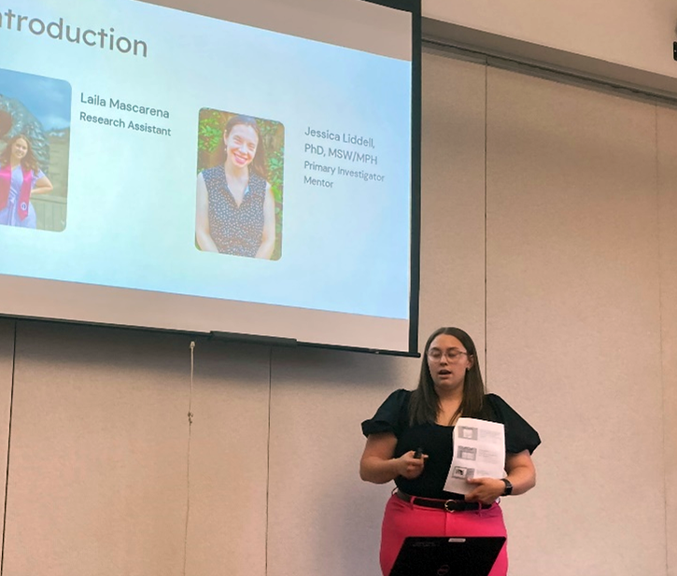
Laila Mascarena presenting at the 22nd annual UM Conference on Undergraduate Research
We’re pleased to share that Laila Mascarena, a recent BSW graduate, received an Honorable Mention (second place) for her oral presentation in Social Sciences at the 22nd annual UM Conference on Undergraduate Research! Alexis Gibson, Director of the Office of Undergraduate Research, wrote, “The judges were thoroughly impressed with [Laila’s] work, and we are proud to have [Laila] among our presenters.”
Laila’s presentation, “Exploring Barriers and Facilitators to Accessing Reproductive Healthcare in Rural Montana,” described her efforts and learning as a part of her research assistantship with Dr. Jessica Liddell.
Congratulations Laila!
Faculty News

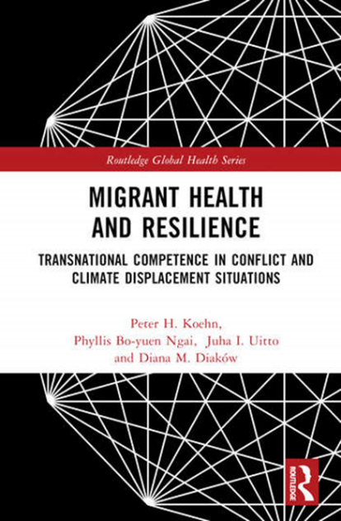
Dr. Phyllis Ngai, Clinical Associate Professor, has published a newly co-authored book in Routledge’s Global Public Health Series - Migrant Health and Resilience- addressing the transnational migration crisis. In an era of escalating migration and cross-border interaction, transnational competency preparation for displaced persons, members of their host communities, humanitarian responders, social workers, and healthcare professionals are critical. Addressing a range of humanitarian and environmental crises and global justice contexts, this volume provides practical guidelines for preparing effective responses to health and other challenges arising from population dislocation. Migrant Health and Resilience (with a link to the Open Access option) will be essential reading for students, instructors, scholars, and evaluators in social work and related helping professions.
Huge congratulations to Dr. Ngai on this amazing achievement!
You're receiving this update because you're part of the UM School of Social Work community.
University of Montana – School of Social Work • Jeanette Rankin Hall • Missoula, MT

