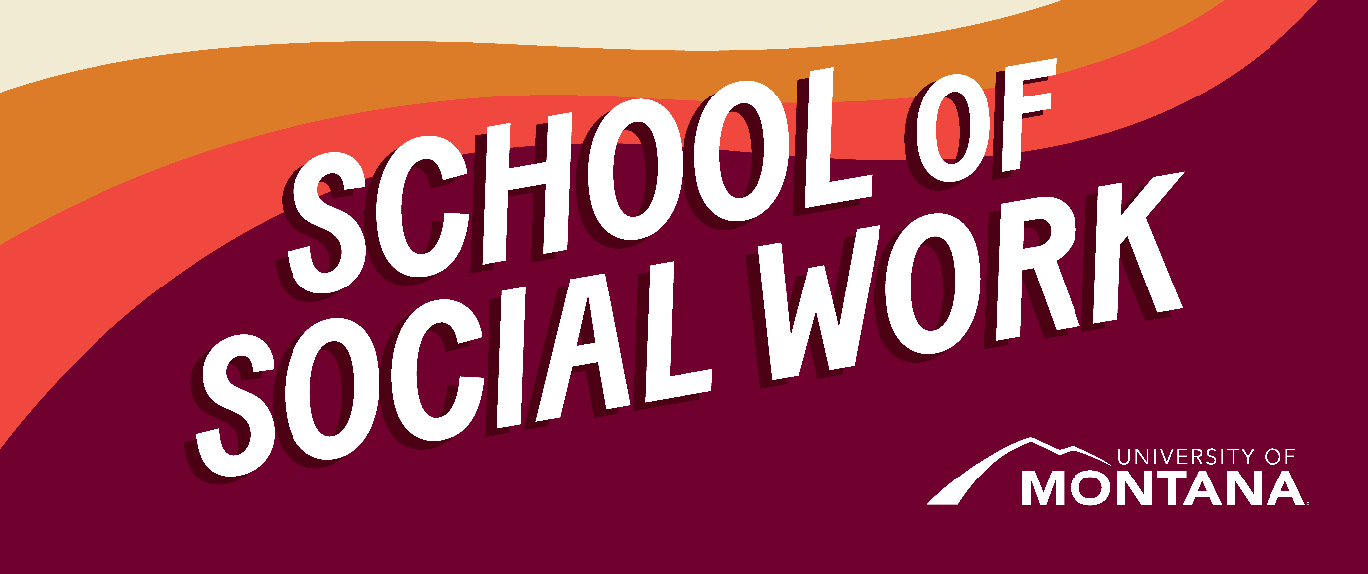
What's Up – A Newsletter from the UM School of Social Work
Social Work is Political
By Amanda Cahill
“Power without love is reckless and abusive, and love without power is sentimental and anemic. Power at its best is love implementing the demands of justice, and justice at its best is power correcting everything that stands against love.” Dr. Martin Luther King, Jr.
As we move into election season, we ask that you consider your role as social workers and what drives you to this profession. You may have come into your education with existing deeply held beliefs about social justice, or you may be in the process of figuring out where you land on issues- both of those are great places to be in. Views on issues can and should be consistently evolving for all of us. This is especially true if we are doing the continual and intentional work of learning about policy issues. This month we want to draw your attention to the National Association of Social Workers and their News Releases. Here you will find positions and statements put out by the NASW on a variety of topics, from endorsing political candidates to calling for police reform. These statements are excellent for students to read as each one articulates the grounding social work principles behind the stance.
Register Today: Voting Is Social Work Webinar
CSWE
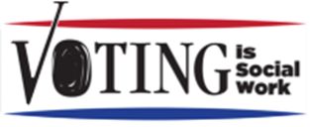
CSWE is partnering with Voting is Social Work to offer a voter mobilization webinar. As a social worker during this election year, your voice is critical. Imagine if all 700,000 social workers in the United States each registered three people to vote—we could change the political landscape. Join us for the "Electoral Activism: The Urgency is Now!" webinar on Thursday, September 26, 2024, from 1:00–2:00 PM (ET). Attendees will gain insights on how to leverage their skills through voter engagement and bring awareness to their clients, communities, and the profession. Register now and be part of this critical movement. Register here.
https://cswe.zoom.us/webinar/register/WN_nbTjHIEaTh-Nmn5whOYULA#/registration
Canvas
We are now using Canvas as our sole Learning Management System (LMS). We know this is bumpy and there is a learning curve. Please reach out to your instructor with specific needs/concerns if something looks odd or is confusing. Screen shots help!
Handbooks
UM School of Social Work Handbooks are where you can find all the most recent policies for each program. Please review the handbook for your respective program:
BSW Handbook
MSW In Person Handbook
MSW Advanced Standing Handbook
Online MSW Handbook
Restorative Justice: Please attend to learn more and get involved
By Dr. Jen Molloy
The Missoula County Community Justice Department is hosting a Lunch and Learn on Restorative Justice (RJ). I will be providing an overview and leading the discussion on September 18th at 12PM, in the Missoula County Courthouse - Sophia Moiese Room (across from Liquid Planet).
The Lunch and Learn will answer the following questions:
- What is RJ? What it isn’t?
- What does Missoula have currently?
- What are other communities doing?
- What resistance is there to RJ?
Intended Outcomes: meet others interested in RJ, increase & build common understanding of RJ continuum, name concerns, cover projects in Missoula.
The Community Justice Department will be hosting monthly short, accessible, in-person/hybrid trainings, that offer professionals across the legal, behavioral health, recovery, and houseless system of workers and community agencies to meet and collectively explore topics of shared concern. Future topics may include: Desistence of crime; Avoiding burnout; Trauma-informed departments; Traumatic Brain Injury. Reach out to Jenny Daniel, Justice Initiatives Manager, at jdaniel@missoulacounty.us to learn more and to RSVP for this event.
Recent Grad Spotlight: A BSW Graduate Continues to Lead Suicide Prevention Efforts
By Katie Karas
Brittany Blair completed an employment-based practicum as the Program Manager of the 988 Suicide & Crisis Lifeline Services (also known as the National Suicide Prevention Lifeline Center) at Western Montana Mental Health Center during the 2023-2024 academic year. After graduating with her BSW degree in the spring of 2024, Brittany was excited to be promoted to the Director of this essential program! Over the last four years, she has played a significant part in the program’s success in serving individuals experiencing crises in seven local Montana counties. In her current role as Director, Brittany provides supervision of crisis call specialists, manages two state awarded grants and one federally awarded grant, maintains accreditations for 988, and fosters relationships with community and agency partners. Brittany's professional growth, both during her BSW program and following graduation, are a great example of the phenomenal work that our BSW students and graduates do in Missoula and around our state.
Faculty News: UM's SSW Faculty Member Appointed to National Leadership Role
The Council of Social Work Education (CSWE) Board of Directors appointed Dr. Phyllis Ngai, Clinical Associate Professor, as a member of the CSWE Council on Global Learning and Practice (CGLP) for a 3-year term effective July 1, 2024-June 30, 2027. CGLP works in concert with the Commission on Global Social Work Education, with specific goals of developing the CSWE agenda for understanding, stimulating the international parameters of social work education, and shaping the accreditation process.
Dr. Hilary Weaver, Chair of CSWE Board of Directors, explains in the appointment letter: CGLP Members are entrusted with a pivotal role in shaping the future of social work education and upholding the highest standards of social work education in the areas of global learning and practice. This appointment recognizes Council members’ outstanding reputation, and the trust placed in the Council members’ qualifications and abilities by the social work community. Council members’ expertise and insights will contribute to promoting excellence and advancing the quality of social work programs nationwide.
The Global Commission on Social Work Education’s charge and the Council on Global Learning and Practice’s charge, as per the CSWE bylaws, can be found on the CSWE webpage.
Field Education at a Glance
By Kat Werner
The UM School of Social Work has experienced significant growth in student enrollment, which has brought an increase in practicum placements. This expansion has enhanced the diversity of learning opportunities for students, both across Montana and nationally, and has also enabled the development of more paid options, such as stipends and employment-based placements. The rise in hours worked and the corresponding service contributions reflect the increasing impact students are making in their communities, including in many rural and Indigenous areas. These are changes with positive impacts, making the practicum experience more accessible and supportive of students’ personal and professional growth. Overall, the numbers demonstrate that the field education program is not only expanding but also improving the quality of opportunities it provides, ultimately benefiting agencies, clients, and communities.
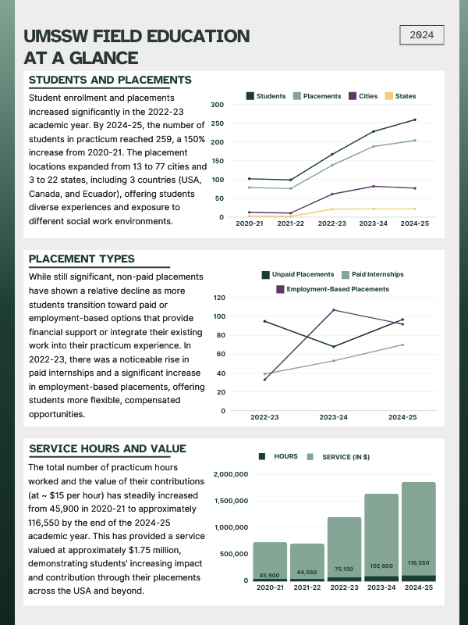

STUDY ABROAD ELECTIVE COURSE IN GERMANY SPRING 2025
Zak Reimer, Adjunct Assistant Professor, and Kat Werner, Associate Clinical Professor, are offering a 3-credit travel abroad elective course to Berlin, Germany in the spring of 2025. on This immersive program focuses on refugee resettlement, immigration, and social justice and will not only enhance your understanding of social and historical justice and refugee issues but will also provide a hands-on experiential learning experience in Germany.
For more information:
- Register HERE for a 45 minute info session on Monday, September 30 at 9am MST. This session will cover a detailed course and credit overview, spring 2025 dates, itinerary highlights and activities while abroad, and program costs for campus and online students. You will also hear from two students who traveled to Berlin last year and will share firsthand about their experience!
- You are also invited to email Kat or Zak any time: katharina.werner@umontana.edu and zak.reimer@mso.umt.edu
Financial Aid Issues
It has recently come to our attention that there is a significant delay in many people’s financial aid. We recognize this has incredible impacts on many of our students. If you are struggling with this, please reach out to Ashley Trautman and/or utilize the services below:
- UM Food Pantry
- FAST Fund – students can apply for money, typically between $100 -$300 for a one time emergency need. Funds cannot be used to pay tuition. Students should clearly articulate how their situation is an emergency.
- Wellbeing Coordinators to work help students work through stress and challenges
- Financial aid advances: We’ve had success in helping one student receive an advance from Business Services. In order to be eligible for an advance students must have completed all required loan counseling and credit checks. If a student is interested in this path, please contact Ashley Trautman.
We are deeply concerned about this issue and will be advocating for: further information and communication, for waiver of all late fees, and other items to better serve students.
You're receiving this update because you're part of the UM School of Social Work community.
University of Montana – School of Social Work • Jeanette Rankin Hall • Missoula, MT

