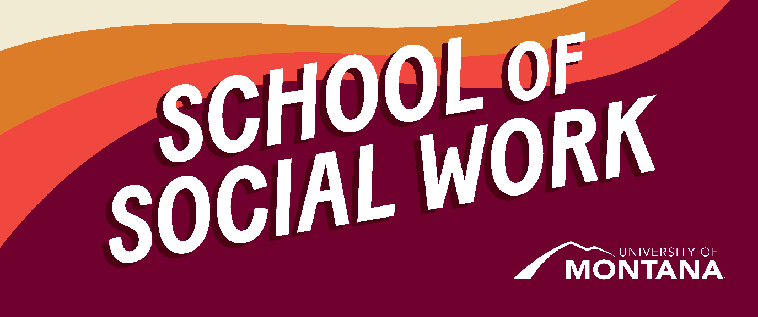
What's Up – A Newsletter from the UM School of Social Work
Welcome to Fall Semester!
By Amanda Cahill
Connection with others is the antidote to the heaviness that many of us are experiencing. What does this look like; consciously making an effort- text a friend you miss, plan an evening get-together, attend some live music or a fall festival. Remember that you’re a human with a biological need for closeness and community. If you are feeling intense loneliness or isolation, please reach out for support and help.
A Message from the Chair
By Sarah Reese
I am very excited to begin my first fall semester as Chair of the School of Social Work. One thing I am very committed to in this role is to hear directly from you as students about what is most important to you. We have a couple of ways for you to make your voices heard.
- We are currently recruiting for the Student Evaluation Committee (SEC). The SEC is integral to our annual evaluation of faculty through reviewing all course evaluations and creating reports from the perspective of students to be reviewed by other faculty and university leadership.
- We are currently recruiting for the Student Advisory Council, which will be led by Graduate Assistance and provide ongoing guidance to School leadership. If you are interested in either of these opportunities, please reach out to me.
- In addition to these groups, I will be meeting with students monthly on zoom for “Chats with the Chair” during the following days and times. Please join me to introduce yourself and bring your ideas and concerns. Please always feel free to reach out by email or stop by my office in Jeanette Rankin Hall Rm 004.
Zoom Link: https://umontana.zoom.us/j/3246116459
- Meeting Dates (12:00–1:00pm MT)
  - Friday, September 12
  - Friday, October 10
  - Friday, November 14
  - Friday, December 12
  - Friday, January 9
  - Friday, February 13
  - Friday, March 13
  - Friday, April 17
Research Study Opportunity
By Hannah Knipp
Dr. Hannah Knipp, an Assistant Professor in the School of Social Work at the University of Montana and a former school social worker, is recruiting participants for a research study to learn how state and federal educational policies related to sexual orientation and gender identity impact schools and school-based mental health professionals. Please see the study brochure for more information.
School-based mental health and behavioral health professionals (including student interns) working in Montana schools are invited to participate in the study. Please note that participants do not have to be employed directly by the school to participate. Participants will share their experiences in a one-one-one interview with Hannah for approximately one hour, over zoom or in-person. Interviews are confidential.
Please feel free to forward this email to anyone who might be interested in participating. If you have questions or would like to learn more about the study, please email Hannah at hannah.knipp@mso.umt.edu. If you are interested in participating in an interview, please sign-up for an interview time or email Hannah directly. Thank you for the important services you provide in our public schools and for your time and consideration.
View a recent article by Dr. Knipp Parents’ rights actually mean every parent, not just some: Navigating parental rights in public schools under the pending threat of anti-LGBTQ+ legislation | Education Policy Analysis Archives
Global A Message from the Field Education Team
By Kat Werner, Katie Karas, Jen Barile, Sarah Fielding, Kimmie Garner & Tomas Hernandez
Dear Social Work Students,
As we reflect on the 2024–2025 academic year, we want to celebrate you. Through your practicum experiences in Missoula, across Montana, and beyond, you demonstrated remarkable skill, resilience, and compassion. The feedback we have gathered from Agency Field Instructors and from your own reflections shows the meaningful difference you are making in your agencies, with clients, and in communities across the state and country.
Your commitment to justice and healing inspires deep hope. This year, many of you partnered with Indigenous and rural communities, expanded access to services, and brought creativity and courage to complex challenges. Step by step, you are moving the needle of social, racial, economic, and environmental justice.
At the same time, we are all navigating a rapidly changing political, social, funding, and workforce landscape. It can feel overwhelming at times, and hard to know where to begin in pushing for change. Years ago, I saw a postcard in a German bar that simply said: “To start everything, start anywhere.” Each of you is embodying that wisdom - taking action in your placements, communities, and classrooms to create positive change, one step at a time.
We have put together a short recap highlighting your impact and hours of service, which you can view in the attached flier. It is a snapshot of what you accomplished this past placement year - and it is impressive!
Social work has always been a bridge toward justice, built on empathy, equity, and possibility. All of you showed that you can hold the boat steady and embody the change our world needs. Thank you for the energy, passion, and care you bring to this profession - we are so proud of you!
With appreciation,
Your UMSSW Field Education Team
Kat Werner, Katie Karas, Jen Barile, Sarah Fielding, Kimmie Garner, & Tomas Hernandez
2+2 Welcomes 50 New BSW Students from Across Montana!
This Fall, the School of Social Work welcomes one of the largest cohorts of 2+2 cohorts since the program began. The 2+2 program is a partnership between the School of Social Work, tribal, and community colleges throughout the state that creates a pathway for students to complete their undergraduate degree in Social Work without having to leave their home communities.
New Year, New Faces
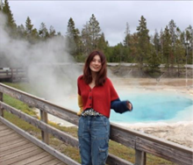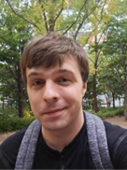
Yusi Chen Gage Weston
Graduate Assistants (GA) support the Social Work Program in so many ways. This year, we find ourselves grateful to begin the year with two GAs ready to support students, the Social Work program, and broader campus community. Please welcome first-year MSW students, Yusi Chen and Gage Weston as GAs for the BSW and MSW programs.
September 27-October 5th is Climate Solutions Week!
Join Climate Smart Missoula and partners for Missoula's third-annual Climate Solutions Week! Launching with CilmateFEST in Caras Park, there's something for everyone – with over 20 free events, from workshops and panel discussions to solar house parties and sustainable fashion. Find your joy and plug in Sept 27 - Oct 5. Details at MissoulaClimate.org/solutions.
ClimateFEST
Kickoff Climate Solutions Week in Caras Park with the 7th annual ClimateFEST! Featuring dozens of local organizations and businesses, this free, family-friendly event celebrates climate solutions – from renewable energy and electrification to transportation and education, to art and advocacy. There's something for everyone! Join the fun Saturday, September 27th from 10am-2pm in Caras Park. Details at missoulaclimate.org/climate-fest
Group Opportunity:
Thriving amidst climate chaos: Skills for turning threat into resilience
Sunday, September 28 | 4-6pm | GW Marks Exploration Center, Balsamroot Room - 1075 South Ave. W.
If you’ve experienced anxiety, grief, or difficult emotions related to our changing climate, you’re not alone. The good news? There are science-based strategies that can help us build personal and community resilience, so we can cope with and even thrive amidst climate chaos. Join this free, engaging workshop with Andy Laue, LCSW of Activate Resiliency, focused on building practical skills for navigating climate emotions.
After the 90-minute workshop, stay and connect with neighbors for a community meal. Main dishes will be provided (including vegan/gf options); side dishes to share are welcome. This event is co-sponsored by Climate Smart Missoula, Families for a Livable Climate, Montana Health Professionals for a Healthy Climate, and Tamarack Grief Resource Center.
RSVPs kindly requested HERE. For details about the entire lineup of Climate Solutions Week events, head to missoulaclimate.org/solutions.
Recent Graduate, Christina Bucarey, elected to NASW-MT Board of Directors
By Christina Bucarey, Kinsey Webb
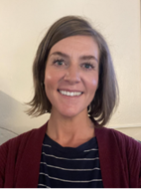
Christina Bucarey
Graduate of the Summer 2025 MSW class, Christina Bucarey, has been elected to the NASW-Montana Board of Directors.
My name is Christina Bucarey, and I recently completed my final year of the MSW online program. I work as a Licensed Addiction Counselor (LAC) on the Flathead Indian Reservation and will be obtaining my LCSW candidate license upon graduation.
I’m excited to share that I’ve been selected to serve as the MSW Student Representative on the NASW Board of Directors. I'm truly honored and grateful for everyone who took the time to vote and support me, thank you!
In this role, I’ll represent student voices and help contribute to important conversations shaping our profession. I’ll also be joining either the Ethics Committee or the Professional Development Committee and look forward to learning, growing, and giving back through this next chapter in my journey as a social worker.
Congratulations to the MSW Class of Summer 2025
The MSW Online program recently celebrated the graduation of its fourth cohort. A virtual graduation ceremony was held for the 44 graduates, and their friends and families.
The graduates completed their MSW degrees remotely across 11 states, two countries, and three time zones. Kimberly Garner, Asst. Director of Field Education and Clinical Assistant Professor, was voted by students to be the Faculty Speaker.
Excerpt from Kimberly Garner’s Faculty Speech
“Three years ago, in August 2022, you each embarked on this MSW journey. You committed to a profession rooted in recognizing and upholding the dignity and rights of all human beings, especially those who have been and continue to be marginalized or stigmatized. You dedicated yourself to examining and undoing your own biases and assumptions. You immersed yourselves in the principles of trauma-informed care, awareness of rural and Indigenous histories and contexts, and countless evidence-based theories and practices. You learned how systemic injustices play out in the individual lives of those you work alongside and developed innovative strategies to challenge and address those realities. You witnessed your clients and communities experience profound joy and loss, and held one another as you experienced the same in your own personal lives.”
Christina Bucarey was voted by students to be the Student Speaker.
Congratulations to the new graduates!
You're receiving this update because you're part of the UM School of Social Work community.
University of Montana – School of Social Work • Jeanette Rankin Hall • Missoula, MT

