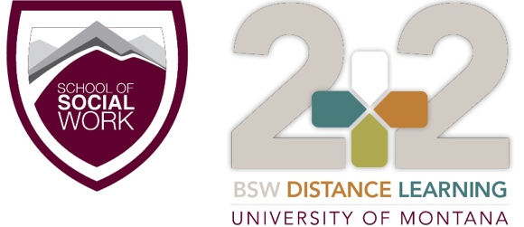

University of Montana Resource Guide

VETERAN
http://www.umt.edu/veterans/Veterans_Support.php
- Open M-F from 8am-5pm and there will always be someone available to speak on the phone.
- As far as using the GI Bill through UM; students submit their request to use benefits through our webpage, http://www.umt.edu/veterans/, by clicking on “Notification of Intent.”
- Veterans with disabilities may be eligible for Vocational Rehab
- (406) 243-2744

AMERICAN INDIAN STUDENT SERVICES
http://www.umt.edu/aiss/About%20AISS/default.php
- Provide a list of scholarships
- Peer mentoring
- As for being off campus the best way to know what is happening in our office and deadlines and scholarships is to friend us on FB AISS UM
- If you have questions concerning your Native American fee waiver you should contact Sarah Wade in the Financial Aid Office 243-5519
- If you have any questions michelle.guzman@mso.umt.edu.
CAREER SERVICES
http://www.umt.edu/career/
- You can utilize any of these services and can set up phone/zoom meetings

DISABILITY SERVICES
http://www.umt.edu/dss/Prospective_Students/default.php
- Reasonable modifications are changes in the learning environment that permit students with disabilities to compete on an equal footing with their peers at the University. The modifications modify non-essential elements of University programs. Students with disabilities initiate the request for modifications and/or services in a timely manner, communicate with faculty regarding modifications, and work with their coordinators as needed.
- http://www.umt.edu/dss/Students/Requesting_Modifications.php

TRIO Student Support Services
http://www.umt.edu/triosss/
- Students are eligible for TRIO Student Support Services if they are seeking their first undergraduate degree and meet at least ONE of the following qualifications and are able to demonstrate academic need:
  - First-Generation College Student - Neither parent (or guardian) completed a four-year college degree before your 18th birthday.
  - Low-Income – You qualify under federal financial guidelines (similar to Pell Grant eligibility).
  - You have a documented physical or learning disability.

RURAL INSTITUTE
http://ruralinstitute.umt.edu/
- Education and Training include Living Well with a Disability, a health promotion program that helps participants reach the quality of life goals through healthy lifestyles.
- The community services include assistive technology demonstration and equipment loan to enable independence at home, school, work, and in the community throughout Montana.
- Research areas include rural transportation and employment options to support economic independence. The 40+ RIIC projects focus on employment, independent and healthy living, education, accessible housing, and transportation to enable rural Americans to be fully included in their communities.

SARC
http://www.umt.edu/student-advocacy-resource-center/SARC%20Office%20Information.php
- If students want to get connected for remote services, they can contact the SARC office at 406-243-4429, or call our 24/7 support line at 406-243-6559
- Free and confidential support for students who have experienced discrimination, sexual assault, relationship abuse and/or stalking
- Free counseling and advocacy

