Phyllis J. Washington College of Education and Human Sciences Communicative Sciences and Disorders RiteCare Speech, Language, and Hearing Clinic
32 Campus Drive
Missoula, MT 59812-6695
CSD Office: (406) 243-2363 Fax: 243-2362
Clinic Office: (406) 243-2405 Fax: 243-6678

Name:
Phone number: Email: Organization: Site address:

Briefly describe your clinical site and the typical clients you serve. Include ages, disorders, severity, individual, group, or home based services, diversity of clients, and any other information that will help us understand your site.

Have you supervised before?

Are you ASHA certified?
What is the best time and method to contact you?

Thank you,

Amanda

Amanda Jackson, MS, CCC-­‐SLP Clinical Externship Coordinator University of Montana Communicative Sciences & Disorders
Return to:
amanda.jackson@mso.umt.edu
Office 406.243.2377
Fax 406.243.2362

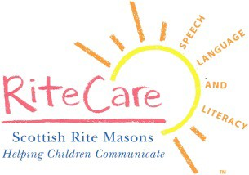
An Equal Opportunity University

