Intro Email for First Time Challenge Participants:
Copy and paste the template below to invite your staff to participate in the Commuter Challenge – or you can write your own. Please note the red bolds and edit as appropriate.
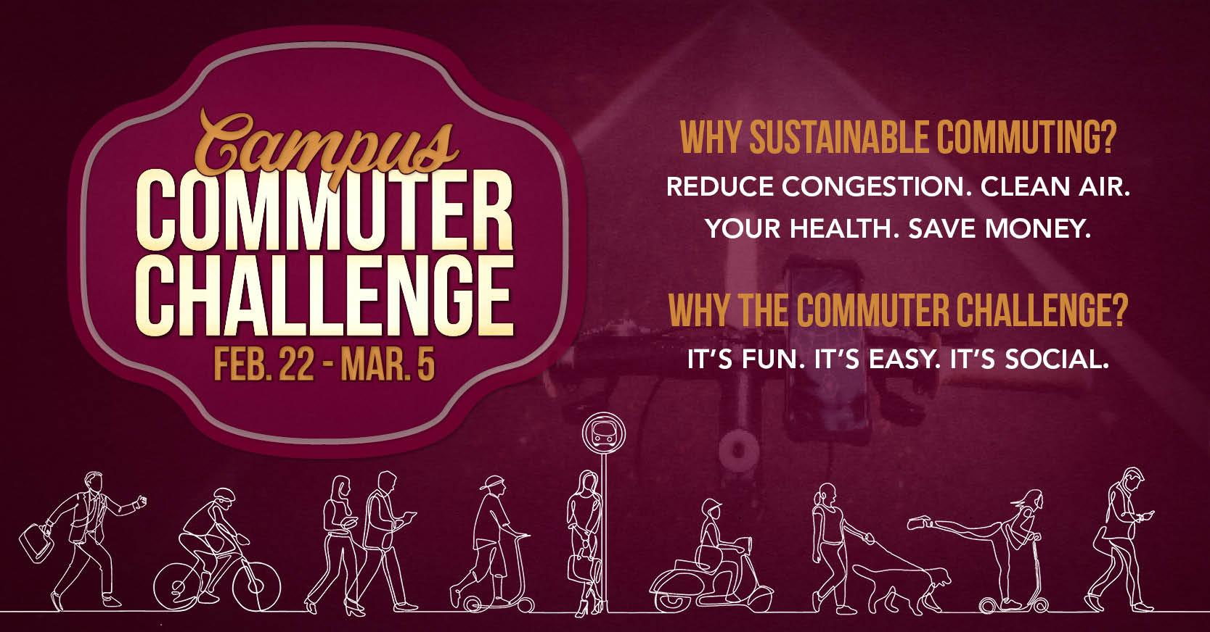

Helpful Hint: You will need to copy and paste the Shareable Join URL that is unique to your Workplace Network. To access the URL: log in to your Way to Go! Missoula account and select the tab for your Department from the “Manage” tab. From there, select the “Edit” tab and you will see the URL specific to your workplace in the upper right-hand corner of the screen.
Decreasing the number of people who drive alone in a car to get to campus relieves parking pressure, decreases congestion and contributes to cleaner air. When one person is able to travel by bus, bike, foot, carpool or vanpool (even just one day a week!), it truly benefits us all.
The UM Commuter Challenge is a department-vs-department competition where teams compete to see who can commute actively and sustainably the most from February 22nd-March 5th. It’s an opportunity to discover ALL our travel options and hopefully try some new ones! There’s some pretty cool prizes, too! And, guys, guess what!? If we are the ONLY team to have everyone commit to traveling by any mode other than driving alone ONE time between February 22nd-March th^{th}, then we WIN. Bus, walk, bike, carpool, vanpool, telecommute. One time, one trip. That’s it. We can do it!

Sign up for the challenge as a member of Team Department Name here: (insert Shareable Join URL)

Now you’re in and you can start logging sustainable commutes and tracking your impact! Watch this How-to-video to see how easy it is to log trips with Way to Go! Missoula.
Signed, XXXXXX
Your Commuter Challenge Captain

