MIBA Student Handbook
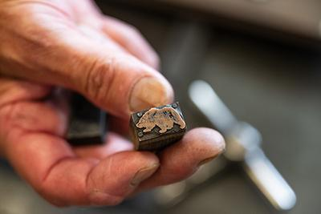

Table of Contents

Enrollment 3
Payment and Cancellation Policies 5
Scholarship Application 6
Schedule Session 1 7
Schedule Session 2 8
Workshop Information 9
Missoula Information 10
Missoula Lodging 12
Yellow Bay Information 13
Yellow Bay Lodging 16
Bear Scratch Press Studio 18
Rules and Regulations 20
Liability Release & Medical Emergency Contact 22
Sign and Submit 23

Enrollment

Classes are limited to 10 people per workshop. This small size ensures one on one time with the instructor and a deeper attention to student work.
Registration opens in February and closes on June 30th. A special extension may open for students if classes are not filled by July 1st, but this is at the discretion of the teacher.

MIBA courses do not currently award academic credits. Rather they are professional workshops for people seeking skills outside the university system.

Classes may fill up quickly and enrollment is first come first served.

How to Register:
- Navigate to https://www.umt.edu/um-press/miba/register/default.php
- Enter your contact information in the form provided.
  - Make sure you fill out your email correctly, as this is how we contact you for next steps.
- Select how many sessions you are attending.
  - For example, if you are only attending the 2nd session, select “1 Session” but if you are attending both the 1st and 2nd session, select “2 Sessions”
- In the next dropdown question, if you are only attending 1 session, select which session you are attending (1st or 2nd)
- Select your workshop for each session.
  - Each session will have a dropdown. Select your workshop for each session. If you are not attending one of the sessions, leave it blank. If a class is sold out, it will be removed from the website.
- Click “Send”
  - Your information will be registered with MIBA staff, who will reach out to confirm your enrollment. Expect 2-3 business days for a response. Check your junk inbox if your email filters unknown senders.
How to Pay:
- Proceed to the Payment Portal by following the link at the bottom of the confirmation page.
- Select which sessions you are purchasing: Both Sessions, Session 1, or Session 2.
- Fill out your contact information again (this is filed in a separate system for payment).
- Select your workshop (one per session).
- Select “Add to Cart”
- Go to your Cart (banner at top of page)
- Click “Checkout”
- Select “Continue as Guest” or you may register for an account (guest is faster)
- System requires 2 factor authenticator, so add phone number for a code verification
- Once you’ve entered your code, you will be able to add your billing information.
- A receipt will be emailed to you.

Payment and Cancellation Policies

Enrollment is considered complete once you have paid in full.
- You must pay in full by June 30th.
- For payments made before May 31st
  - you have 1 week to cancel (send an email to daniela.garvue@umt.edu) and receive a full refund. Afterwards, MIBA will retain a $100 processing fee.
- For payments made after May 31st
  - if you need to cancel, MIBA will retain a $300 processing fee, and refund the remaining balance.
- Cancellations after June 30th are nonrefundable.

Scholarship Application

The University of Montana will be awarding one scholarship to a dedicated UM student, and one scholarship to a Missoula community member.

Montana Institute for the Book Arts
Filter-Koch Scholarship

Please write two or three paragraphs describing your interest in attending the Montana Institute for the Book Arts. Please indicate which workshop you would prefer to attend in descending order, subject to room in the class.
Include your experience in the book arts or related fields, what you feel you may offer the program as a student and artist, and how you hope to apply your knowledge to the broader community.
Note: Newcomers to the book arts are welcome. We will prioritize applicants who are driven to build a book arts community in Montana.
Submit your application in a word document to daniela.garvue@umt.edu before June 1, 2026.
Include: Your full name, birth date, address, phone number, and email.
You may attach relevant media (photos, website links, etc) if it is pertinent to your application.

The committee will review all applications and respond by June 15, 2026.

Schedule Session 1
Sunday August 2nd:
6-8 pm Meet and Greet at The Rhino downtown
158 Ryman St, Missoula, MT 59802
Monday August 3rd:
Classes
Open Studio 5-10 pm
Tuesday August 4th:
Classes
Open Studio 5-10 pm
Wednesday August 5th:
Classes
Open Studio 5-10 pm
Thursday August 6th:
Classes
Open Studio 5-10 pm
Friday August 7th:
Classes
First Friday Art Walk and Lectures
5:00 Lectures and Panel Discussion: Stephanie Stillo and Cristina Favretto
Missoula Public Library
455 E Main St, Missoula, MT 59802
Saturday August 8th:
Free Day

Schedule Session 2
Sunday August 9th:
6-8 Meet and Greet
Location TBD
Monday August 10th:
8:00 Shuttle departs Holiday Inn Missoula
10:30 Check in Yellow Bay
12:00 half day classes
Tuesday August 11th:
Classes
7-9 pm Whiskey and Wine Tasting courtesy of Kevin Head and The Rhino
Wednesday August 12th
Classes
Thursday August 13th
Classes
Friday August 14th
10 am Check Out
Classes
4:00 Shuttle departs Yellow Bay
6:00 Shuttle arrives Holiday Inn Missoula
Saturday August 15th
Free Day

Workshop Information

Be prepared for class from 8:00 a.m. – 5:00 p.m. Monday – Friday, with breaks for lunch. Your specific workshop schedule may differ, so stay tuned for updates posted online and sent to you via email as soon as instructors finalize their schedules.

If your preferred class is full, you may be added to a waitlist by emailing daniela.garvue@umt.edu
In the meantime, we recommend you enroll in your second choice class. You will learn something new, and you will have time to collaborate and share knowledge across genres.

If a workshop has not reached at least 5 students by June 30th, the instructor has the discretion to cancel the class. Enrolled students may transfer to other workshops in either session, or receive a full refund.

Some classes may require a materials fee, or you may need to purchase special tools before your arrival. In either case, your instructor and MIBA staff will contact you about these materials.

Classes will be held in shared University spaces. Please be respectful of the space and other people.

Please note that due to the age of UM buildings and space limitations, not all classrooms are ADA accessible. Please reach out to daniela.garvue@umt.edu if you have mobility concerns and we will do our best to work with you.

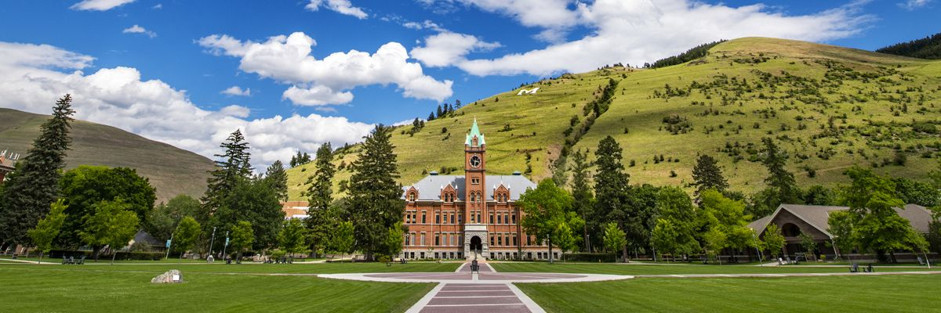
Missoula Information

Getting to Missoula
It's easy to fly in and out of Missoula. Find flights through Alaska, Allegiant, American, Delta, Sun County, or United Airlines. Follow this link to find a flight from your region.
Missoula’s new airport also has great local food and rental car services. You won't need a car to enjoy our program, but you may want one to explore the area on your own time.

Meet and Greet
We recommend arriving the evening before the first day of your session. On Sunday, August 2nd, MIBA will host a meet and greet, where you can get to know your fellow students and teachers. Time and location TBD, so check your email once you are enrolled.

About Missoula
Missoula is a bustling town at the meeting of five rivers, and at the edge of multiple wilderness areas. This land is the home of the Salish and Kalispell people. The name Missoula derived from the Salish placename Nmesulétkw, which means “the place of freezing water”. This name has been used since the existence of Glacial Lake Missoula, and dates to the last ice age. You can still see traces of the great glacial lake on the mountains above campus. The first settlers to arrive here borrowed and modified this name to become Missoula. Later, Salish people began using an additional term for Missoula: Nłʔáyčstm, which means “place of the small bull trout.”

Missoula has great bars, restaurants, art galleries, and a thriving music scene. Check out this link to Missoula Events to see what's going on in town. Missoula also is the access point to hundreds of miles of wild lands and rivers. A favorite pastime during the summer is to float through town on the Clark Fork River.

Eating and Drinking
Students will be responsible for their own meals. However, MIBA will host a few group lunches, dinners, and cocktail hours throughout the week, dates TBD. Please let us know if you have dietary restrictions.

About the University of Montana
UM's beautiful campus sits just across the river from downtown, and it dates back to 1895. It is Montana's flagship liberal arts university, and home of the Griz. Bear Scratch Press and the Book Arts program are fostered by the Creative Writing department, nationally recognized for its influence in American literature.

Missoula Lodging
Housing is not included with the first session in Missoula. We have courtesy blocks reserved at the Holiday Inn and the University Comfort Inn.
Book early, as Missoula is a popular tourist destination in the summer.
Holiday Inn
The Holiday Inn downtown is a 10 minute walk to campus.
200 S Pattee St, Missoula, MT 59802
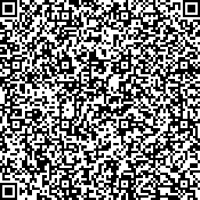
Scan this QR Code for the Holiday Inn, or follow this link to their website.

University Comfort Inn
The University Comfort Inn is conveniently located just across the river from UM’s campus.
1021 E Broadway St, Missoula, MT 59802
Click this link to book with the University Comfort Inn.

Yellow Bay Information
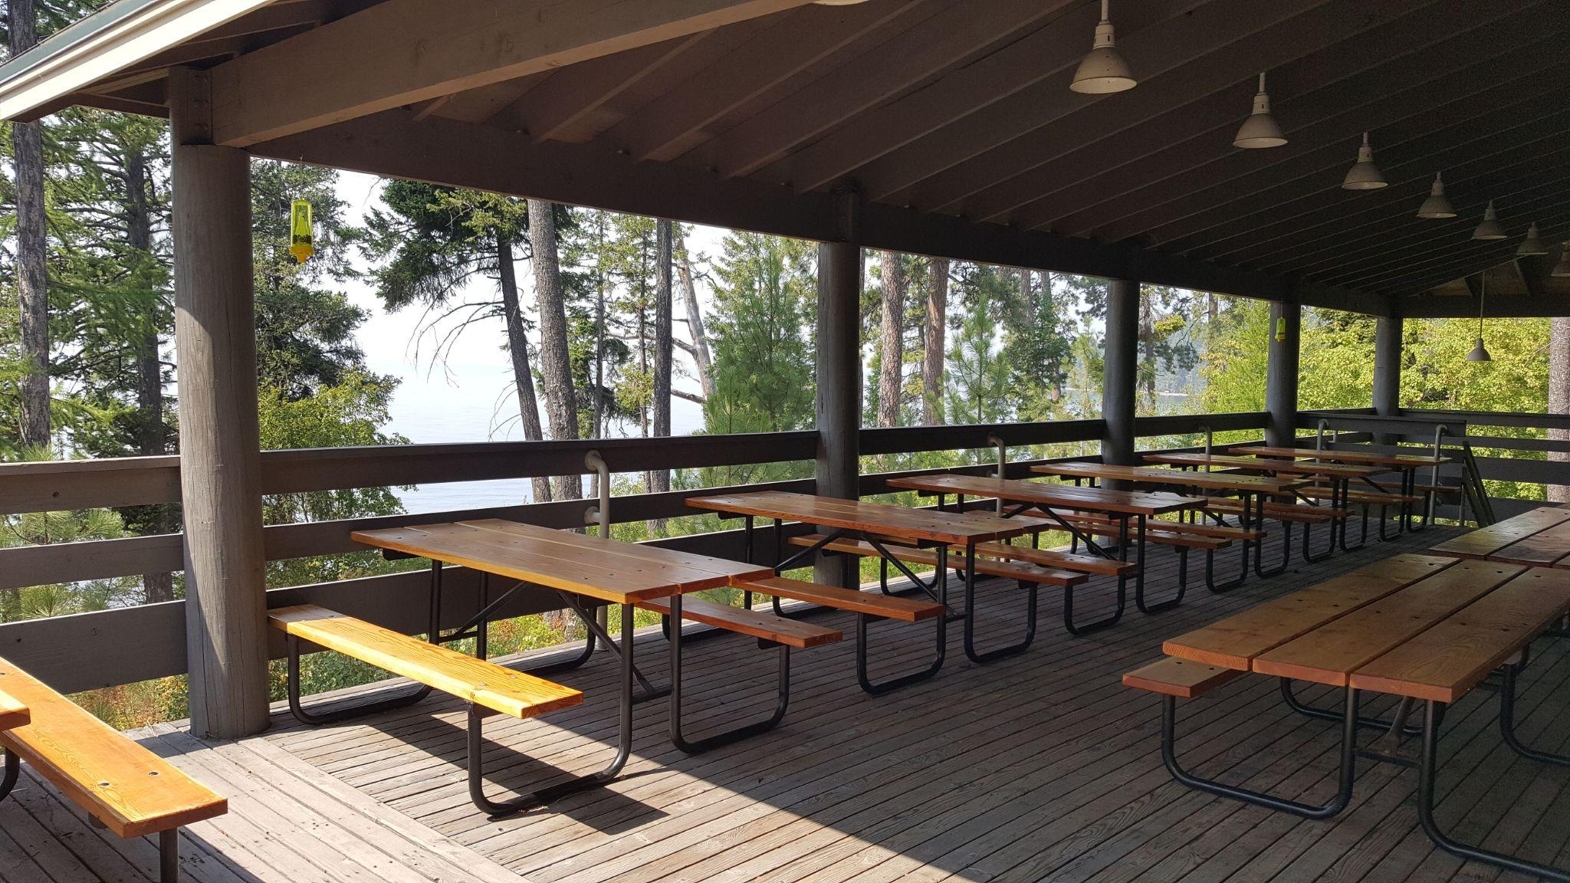

Getting to Yellow Bay
Yellow Bay is a cove on the east side of Flathead Lake, about an hour and a half north of Missoula.
If you are flying in, we recommend you land at the Missoula airport. MIBA will arrange a group shuttle to bring attendees from Missoula to Flathead Lake and back. If you fly into another airport or plan on renting a car, you will be responsible for transporting yourself.

Shuttle Schedule
Monday August 10: Depart from Missoula at 8:00 a.m. and arrive at Yellow Bay at 10:00 a.m.
Friday August 14: Depart Yellow Bay at 4:00 p.m. and arrive in Missoula at 6:00 p.m.

About the Flathead Lake Biological Station
Established in 1899, Flathead Lake Biological Station is an 80-acre campus on the east shore of Yellow Bay on Flathead lake, just south of Glacier National Park. The station serves as the “Sentinel of the Lake” and has been rigorously monitoring the water quality of Flathead Lake since the 1970s. FLBS scientists conduct world-class and world-renowned ecological studies, which are regularly published in top scientific journals. We will be sharing the space with a number of environmental researchers, so please be respectful of their important work. This is a link to their campus map and lodging information.

MIBA will have access to student and staff cabins, the lodge, and two main halls. Meals will be catered, but you can buy your favorite snacks in Missoula and keep them in a small shared kitchen onsite. This is a remote campus, and if you do not plan on renting a car, you will have very limited access to towns or supplies. We will arrange shuttles to take people to and from Missoula.

Eating and Drinking
All meals at Yellow Bay will be catered by Qene’s Catering, an Indigenous-based food service local to the area. Please let us know if you have dietary restrictions or other needs, and we will communicate them to the catering service.

If you have a car, you may also drive into Polson or Big Fork to try local restaurants.

If you have favorite snacks, we recommend picking them up in Missoula before we drive up to Yellow Bay, as transportation will be limited.

Please note that not all classrooms, lodging spaces, and recreation areas at FLBS are ADA accessible. Please reach out to daniela.garvue@umt.edu if you have mobility concerns and we will do our best to work with you.

Yellow Bay Lodging
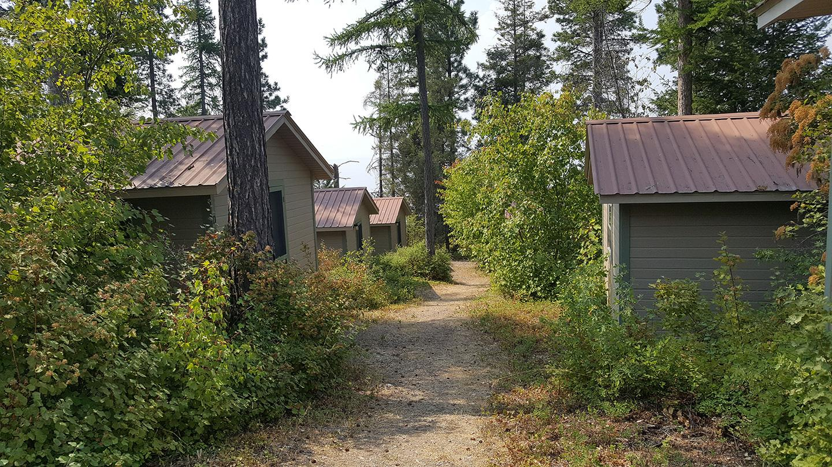

Lodging at Yellow Bay is included onsite with your registration.
You will have your choice of shared cabins. These are first come first served.
If you have specific lodging requests, contact daniela.garvue@umt.edu and we will do our best to accommodate you.
Available Lodging
26 standard cabins with 2 twin beds each -shared bathhouse (like a campsite)
6 lodge rooms with 1 queen bed each -indoors(dorm style) with indoor restroom and small residential kitchen
4 lodge rooms with 2 twin beds each
7 faculty F-Cabins with 1 queen bed each -shared bathhouse only available to F cabin guests
8 faculty F-Cabins with 2 twin beds each
See map below for detail.
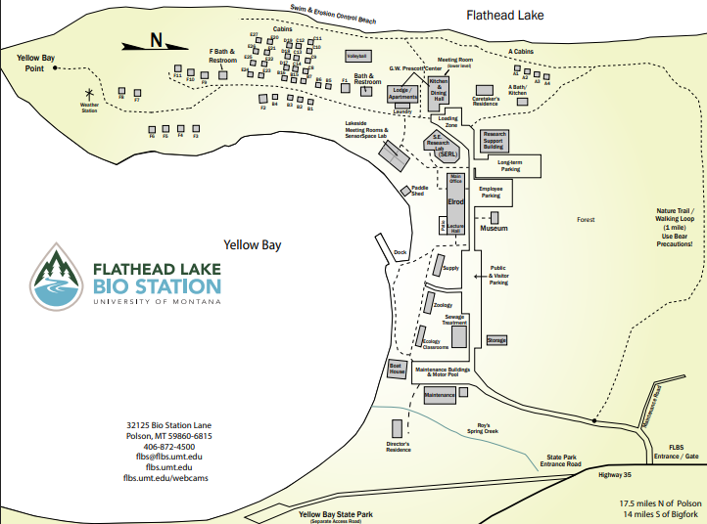

Full PDF map here: https://flbs.umt.edu/media/xlyfdfph/flbs-grounds-map-may-2021.pdf

Bear Scratch Press Studio
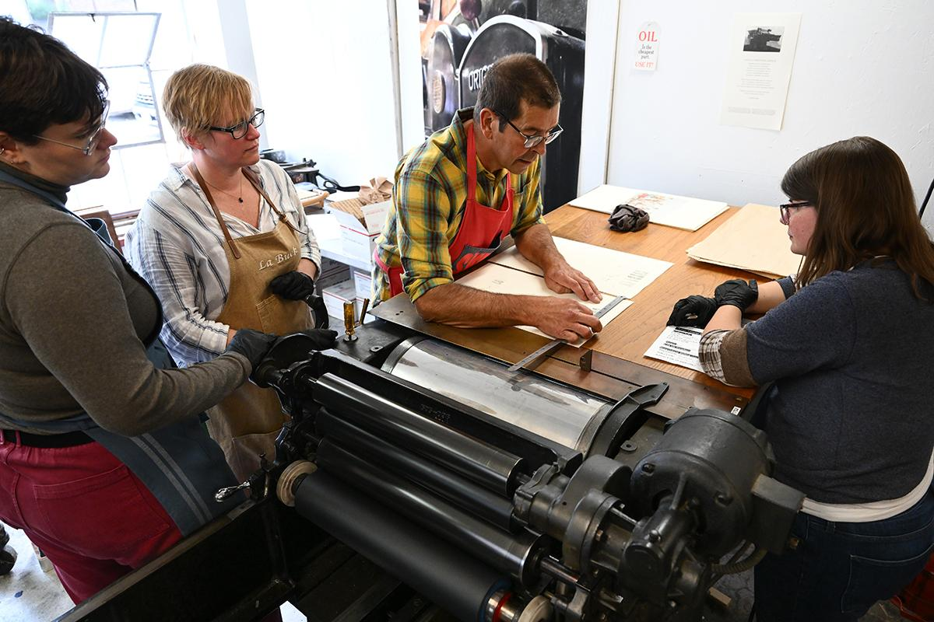

Bear Scratch Press is the University of Montana’s letterpress studio. It is located on the ground floor of Schrieber Hall. In conjunction with the UM Press, Art department, and Creative Writing department, UM offers Book Arts courses in which students can learn skills to operate the mechanical press, print their own broadsides, and learn the history of the literary art form.

Our first press, brought into its new home in Schreiber Gym, was the 1936 Hacker Test Press. It is a hand cranked press with an optional motor that was used to produce some of Peter Koch's finest work, including the Lost Journals of Sacajawea, a collaboration with UM's own Debra Magpie Earling.

On the Hacker and our other presses, a 1957 Vandercook SP-20 and a 1961 Vandercook SP-15, students of the Book Arts program have collaborated with local artists and visiting authors alike to create unique works of art.

Much of Session 1 will be built around our studio and the three presses. We will stagger classes so that each group has access to the studio, but there may be some overlap. Please be patient and respectful of other people’s work.

Print assistants will be onsite to keep the studio clean and organized, and to help with the operation of the press. They will also keep the studio open into the night, allowing students to work on their own projects outside of the class times. Be kind to the print assistants, because they are volunteering their time for the love of the art.

Rules and Regulations

All work spaces during both sessions are shared. Respect the space and be careful with furniture, equipment, and other people’s projects.

At Bear Scratch Press (Session 1)
- If you are unfamiliar with a tool, ask an instructor or print assistant before you use it.
- If you see an unfinished project, do not touch it.
- Store your own ongoing projects out of the way. The instructors and print assistants will show you where.
- Clean up after yourself. Instructors and print assistants will show you what to do. If you don’t know how to clean up, ask. Don’t leave the press or work spaces dirty, as this can ruin the equipment.
- Be gentle and careful with the presses. They are old and parts are hard to find. They are also heavy and can crush fingers and pull hair.
- Access to the Schreiber Building and the Press are contingent on MIBA staff and volunteer capacity.
- The Schreiber Building is home to several other programs, including an art workshop and ROTC offices. Don’t enter classrooms that MIBA doesn’t have access to.
- We will do our best to be available, but there may be times the press is inaccessible because we are sleeping or working.

At Flathead Lake Biological Station (Session 2)
- All the above rules apply.
- The station is home to professional scientists and students who live and work onsite. They are doing important research on climate change, waterways health, and weather prediction, and more. Respect their work and their privacy.
- There are small boats and paddleboards for lake recreation. Follow all posted rules for their use.
- This is a wilderness area. Wildlife and lake conditions are unpredictable. Be aware of your surroundings.
- We will be in the forest during wildfire season. Absolutely no outdoor fires are permitted.

Liability Release & Medical Emergency Contact

Although we do our best to ensure best safety practices in the use of tools and equipment within the studio and in our accommodations, the unfortunate reality is that things can happen. All students will be required to sign a liability release indicating their assumption of the responsibilities and risks involved while attending courses at MIBA. We also ask that students provide emergency contact information and notice of any medical conditions that may impact their experience at MIBA.

Photo Release
We love having photos of our classes! We’ll generally take photos of students working throughout the course, and like to have a class photo at the end where students can show off what they’ve made. These photos are shared with classmates and may be used, with student permission, on our website, newsletters, and other materials. You will be asked to sign a photo release allowing us to use the photos in the future; if you would prefer for your photos not to be shared, you will be able to indicate this on the release form.

Sign and Submit
Fill out this page and email to daniela.garvue@umt.edu

Print your full name below:

Sign and date below to affirm you have read and understand the MIBA Handbook:

Emergency Contact Information
Name:
Relation:
Phone number:
Address:

Please list any dietary restrictions:

Photo Release (circle or highlight):
I do / do not give MIBA permission to share photographs taken of me in associated promotional materials, social media, and websites.

