The Writing Center Assessment Report

2015-2016

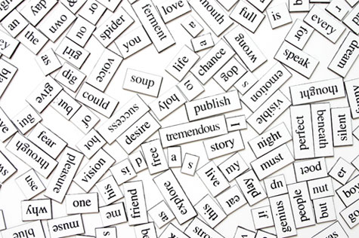

Visit Early. Visit Often.

The Writing Center Mission
As a university hub for campus conversations about writing and other forms of communication, the University of Montana Writing Center administers programs to help undergraduate and graduate students in all disciplines become more versatile and effective thinkers, writers, and readers. In one-to-one and small-group tutoring sessions and whole-class workshops, tutors help students recognize their strengths and weaknesses as communicators and to practice strategies appropriate to various communication contexts. In addition, the Writing Center collaborates with faculty to provide instruction that positively impacts student performance, and supports faculty to promote their own development as writers.

“I’m the first person in my family to pass the eighth grade. I could have never gotten this far without the Writing Center. Total game changer.”
- Social Work Undergraduate Student

Writing Center Assessment: A Reflective, Data-driven Approach to Intervention
We take a reflective stance by engaging in meaningful assessment practices. We embed assessment into our day-to-day work, using a variety of assessment instruments that provide us with continuous feedback.

We aim to assess our impact on student behaviors, attitudes, and performances as well as our influence on faculty teaching practices. In short, we assess the extent to which we transform educators and writers, not just the artifacts they produce.

Writing Center
Assessment Instruments

- Student data tracking
- Focus Groups: undergraduate and graduate students
- Survey: tutoring session students
- Survey: Sidecar faculty and students
- Survey: all faculty
- Survey: Jump Start graduate students
- Observation and reflection: tutors
- Pre- and post- draft assessments:
Sidecar session revisions
Tutoring session revisions

Cover photo credits:
Mount Sentinel and Jumbo: Shuai Yuan, undergraduate student
Letterpress: iStock © mareculiasz
Writing Center objectives and associated outcomes align not only with the university’s mission and strategic issues but also with nationally set standards for supplemental instruction and writing instruction. The Writing Center’s objectives and associated outcomes sit at the heart of our efforts to continuously improve our programs.

- CAS Learning Assistance Programs Standards
- Council of Writing Program Administrator Standards

7,920 instructional student contacts
(2015-2016 Academic Year)

Writing Center Objectives

- Improve students’ writing behaviors
- Improve students’ writing performance/quality of written work
- Positively influence faculty teaching practices across the curriculum
- Foster writing across the curriculum
- Contribute to improved student retention rates and overall GPA

*Each objective includes an associated set of outcomes (see Writing Center Assessment Master Plan).

“Every time I work with UM Writing Center’s staff, I learn something new both about teaching writing and about my own writing process. Their assistance always raises my enthusiasm about writing and teaching writing.
-UM Professor of Sociology

¹33 of this position is Psychology Advising in CHS

Writing Center Tutoring
“The Writing Center tutors are always attentive, knowledgeable, and most importantly, invested… Every time I visit, there’s a diverse range of students and learners around me—from the international student to the 50-year old student to the traditional freshman. It’s been an important asset throughout the duration of my education at UM.”
- Counselor Education Graduate Student and
Undergraduate Alumnus

One-to-one and small-group writing tutoring provide students with on-going writing instruction throughout their academic tenures. Tutors challenge students to think more critically, to consider the rhetorical variables of a writing task—e.g., purpose and audience—and to rehearse strategies to generate ideas, perform research, organize content, synthesize ideas, and polish prose.Highlighted Tutoring Assessment Findings: Student Behaviors and Attitudes
“We’re not here because students can’t write; we’re here because they do.”
- Anonymous, Writing Center poster
Of student Writing Center users surveyed:
- 93% felt challenged during sessions to think more deeply about course content;
- 93% felt motivated to write after sessions;
- 96% used sessions to better address professors’ expectations;
- 100% applied strategies learned during sessions to new writing tasks.

Highlighted Tutoring Assessment Findings: Written Products
As a result of tutoring sessions, students most commonly:
- revised to better fit the assigned genre and to perform the kind of thinking expected by the professor;
- worked to more purposefully prioritize and integrate information;
- revised to move beyond description to write more analytically and argumentatively;
- made major organizational changes to better demonstrate logic and facilitate reader understanding;
- made sentence- and word-level changes for clarity and polish.

85% growth since 2008
32% growth since 2010
Writing Center Actions in Response to Key Findings: Tutoring
Findings | Actions
- 65% of surveyed students visit only when struggling  - 57% of surveyed students view selves as good to excellent writers, compared to their peers | - Develop marketing plan to better define the Writing Center as a place for all writers, including high performing writers  - Develop tutoring strategies to promote accurate self-assessment and continuous growth
- 26% of surveyed students report learning strategies for integrating and synthesizing research | - Develop tutoring strategies to more frequently help students focus on purposeful integration of research and source material
- 288 waitlisted students were unable to schedule an appointment (2015-2016 Academic Year) | - Implement appointment opening notifications via email and text  - Shift appointments to high demand times
- Students feel uncomfortably crowded in LA 144 | - Move to a larger space in the Lommasson Building  - Explore expansion of online tutoring
- Graduate students experience long wait times for appointments | - Add weekly drop-in writing group for graduate students
- Successful post-tutoring session paper revisions require knowledge of both revision strategy/action and the rationale/theory behind the strategy  - Students are more likely to transfer knowledge learned during a session to new tasks if tutors describe the “why” behind writing strategies | - Revise tutor education to promote transfer of rhetorical knowledge through explicit instruction addressing both writing strategies and the rationale behind the strategies
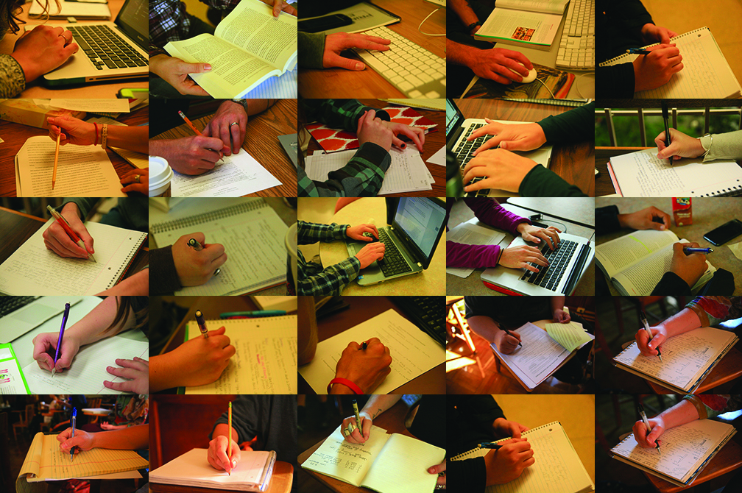
“Hands”
Leah Haemin Kim, UM Student
“Hands”
Created by Writing Center user and undergraduate student Leah Haemin Kim
Sidecar Project
“The Sidecar sessions provided the kind of timely feedback I needed to actually improve my ideas and change my paper. I learned why and how to make revisions instead of just copying suggested edits.”
- Biology Sidecar Undergraduate Student
The Sidecar Project is a course-embedded tutoring model that produces a trifecta of positive influence: improved student writing practices, changed faculty teaching practices, and expanded tutor knowledge.

Highlighted Sidecar Project Assessment Findings:
Student Behaviors, Attitudes, and Perceptions
Of Sidecar student surveyed:
- 87% received more feedback on their writing than in other courses that require writing;
- 92% revised writing more frequently compared to other courses that require writing;
- 86% evaluated and changed their writing strategies;
- 79% better understood professors’ expectations;
- 83% felt pushed to think more deeply about the content of the course.
22 Sidecar collaborations across the disciplines; 550 student participants
Highlighted Sidecar Project Assessment Findings: Faculty Behaviors and Attitudes
Of Sidecar faculty collaborators surveyed:
- 55% assigned more writing as a result of the Sidecar collaboration;
- 100% report the Sidecar collaboration motivated them to rethink their writing assignments;
- 100% will make changes to future courses based on the Sidecar experience;
- 100% report Sidecar students more successfully met their expectations.

Highlighted Sidecar Project Assessment Findings: Written Products and Performance
As a result of Sidecar tutoring, the types of revision most frequently observed in student work include:
- reorganization to better scaffold the argument and prioritize information;
- more sophisticated, deeper thinking (analytical, evaluative, critical);
- cutting of content to provide a more concise and efficient argument;
- attention to reader needs (e.g., logic, coherence, signposting);
- major overhaul revisions are more likely when high professor expectations are clearly communicated.

Writing Center Actions in Response to Key Findings: Sidecar Project
Findings | Actions
- Students desire a Sidecar experience earlier in academic careers (students recognize transferability of skills learned) | - Develop Sidecar collaborations in first-year undergraduate and graduate courses
- Sidecar faculty desire continued support beyond the Sidecar collaboration | - Build a Sidecar faculty “graduate” lunch series for sharing post-Sidecar teaching growth and ideas
- Students often prematurely tinker with/polish prose while avoiding larger, higher-order revision needs (e.g., genre alignment, thesis, support, organization) | - Train tutors to focus on higher-order revisions while providing strategies for later-order proofing  - Collaborate with Sidecar professors to ensure professors explicitly value revisions that reflect better thinking/higher-order concerns
- High expectations coupled with vague communication of those expectations result in revisions that focus only on minor proofing | - Collaborate with Sidecar professors to clarify expectations for written assignments
- Papers in which revisions reflect more sophisticated thinking and logic often remain unpolished | - Collaborate with tutors and Sidecar professors to integrate a polishing stage into the Sidecar sessions  - Collaborate with Sidecar professors to value higher-order revisions as much later-order revisions
Jump Start Thesis and Dissertation Writing Boot Camp
Offered four times each academic year, Jump Start provides graduate students with an intensive week-long writing program. This program provides graduate students with an opportunity to:
“I doubt that I am alone in feeling like the second year of grad school is a lonely experience. I genuinely wish there were more opportunities like Jump Start for grad students to have a space to work, no matter the discipline.”
- Jump Start Graduate Student
- learn effective thesis/dissertation writing strategies;
- gain momentum and make progress in their writing;
- experience a supportive environment for focused writing time;
- develop effective writing habits that will sustain them throughout their careers.

82 graduate students from across the disciplines have completed Jump Start

Highlighted Jump Start Assessment Findings: Student Benefits, Needs, and Perceptions
Graduate student participants surveyed expressed:
- an appreciation for the opportunity to work with a community of graduate student writers;
- a recognition of how learned writing strategies were immediately applicable;
- an intention to continue working with the Writing Center to facilitate completion of degree.

Writing Center Actions in Response to Key Findings: Jump Start
Findings | Actions
- graduate students often misperceive writing as an activity they should be able to “figure out” alone  - graduate students lack awareness of Writing Center services | - Develop marketing plan to better define the Writing Center as a place for all writers, including high performing writers
- graduate students desire expanded writing support (“Jump Start 2.0”) | - Develop a workshop series for graduate students  - Offer additional one-to-one recurring graduate student appointments  - Add weekly drop-in graduate student writing group

“Blocked”
Melissa Unger, UM Student
“Jump Start helped me to actually write. The help that was immediately available pushed me to develop better structure for my work, and the writing strategies we learned helped me to assess my own writing in new ways.”
- Jump Start Graduate Student

Faculty Support and Development across the Curriculum
The Writing Center recognizes faculty as primary partners in its efforts to promote student success. We support faculty through in-class, discipline-specific writing workshops, through faculty development workshops, and through one-to-one faculty consultations. Faculty also work with the Writing Center as they write for publication.
“Working with the Writing Center helped me to see 'holes' in my assignment directions that I had not noticed before. I also was able to better identify the goals I wanted students to achieve with each writing assignment.”
- UM Professor of Public Administration

152 workshops in response to faculty requests;
2,888 student participants
(2015-2016 Academic Year)
80 faculty development workshops and consultations; 165 faculty participants
(2015-2016 Academic Year)
Highlighted Faculty Support Assessment Findings: Faculty Perceptions
Of surveyed faculty:
- 84% refer students to the WC;
- 72% notice an improvement in their students’ writing after a session;
- 87% believe the Writing Center is a critical resource for student success in their courses.

Writing Center Actions in Response to Key Findings: Faculty Support
Findings | Actions
- 30% of the faculty who refer students to the Writing Center do so only when they perceive students to be struggling | - Develop marketing plan to better define the Writing Center as a place for all writers, including high performing writers
- 22% of surveyed faculty use the Writing Center to design writing assignments and to embed writing-to-learn strategies into the classroom | - Develop a marketing plan to better promote direct support for faculty teaching practices  - Recruit faculty to share their successful Writing Center collaboration stories
- 13% of surveyed faculty use the Writing Center for their own writing projects | - Develop a marketing plan to better promote direct support for faculty writing practices  - Recruit faculty to share their successful Writing Center collaboration stories

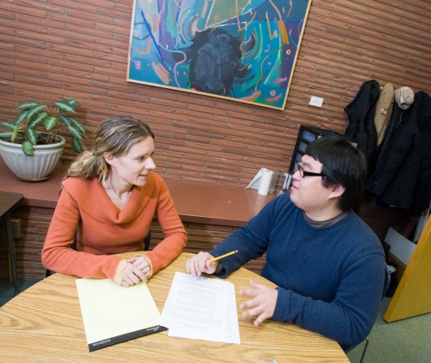
“The Writing Center: A Place for Writers to Talk about Writing”

Looking Ahead: Turing Reflective Assessment into Thoughtful Action

Our proposed actions in each programming category serve to advance a larger set of Writing Center goals. These goals reflect our commitment to continuous quality improvement in our programming.

The Writing Center’s 2016-2017 Academic Year Goals

- Facilitate transfer of effective communication skills across contexts and time through
- Sidecar collaborations with first-year undergraduate and first-year graduate courses.
- tutor training focused on best practices for encouraging transfer of knowledge and skills.
- faculty development opportunities around the concept of transfer.
- Expand graduate student support opportunities.
- Develop a marketing campaign to send the message that the Writing Center serves all writers at all ability levels, targeting those who are less likely to initiate a relationship with the Writing Center (i.e., students who (mis)perceive themselves as “strong” writers, graduate students, and faculty writers).
- Develop low-cost, efficient methods for meeting growing undergraduate, graduate student, and faculty demand for Writing Center services.
- Collaborate with Enterprise Information Systems to gather more fine-grained data on the Writing Center’s impact on student performance (e.g., GPA in specific courses, retention rate, and persistence rate).

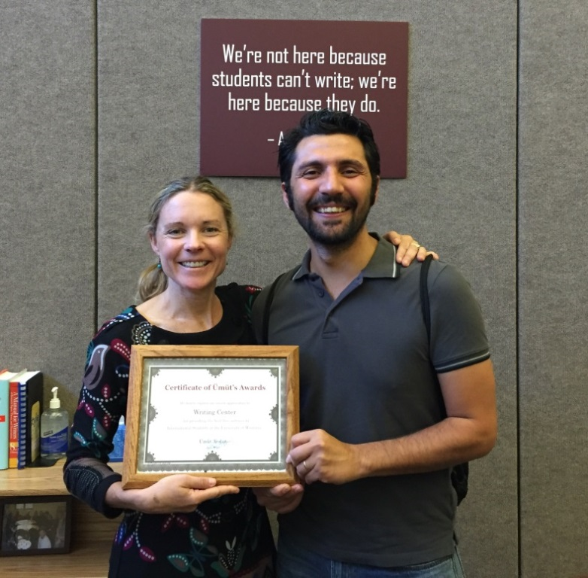
Umut Arslan, UM alumnus, presents the Writing Center director with a certificate of his appreciation
“[The tutors] encouraged my thoughts, helped me to succeed, and worked with me to improve my writing. I will continue to use the Writing Center because I believe it has played a vital role in my college writing success.”

-UM Undergraduate Student

“Working with the Writing Center makes me a better teacher.”

-UM Professor of History

“Tutoring has made me a better writer...and has left this residual desire to be positively involved in students’ education.”

- Graduate Student Writing Center Tutor

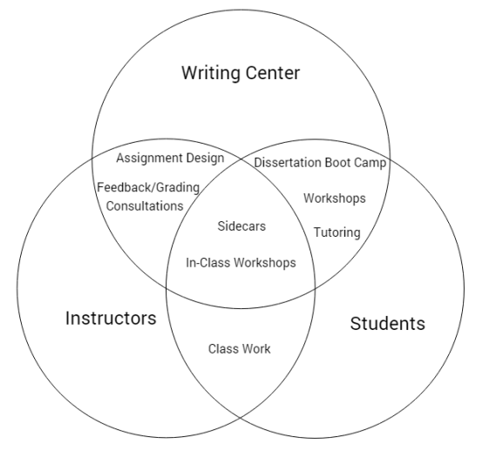

We are a community of
students, faculty, and staff
committed to effective communication.

