Organizing and Integrating Sources
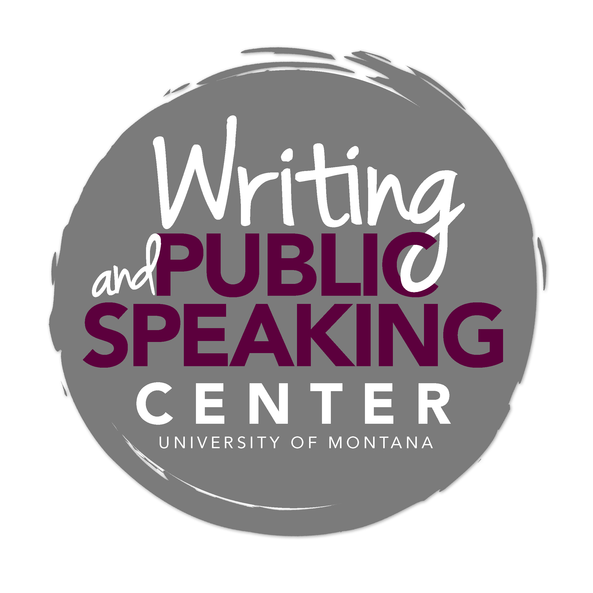

Once you have read and analyzed your sources, paying close attention to the relationships among sources and between each source and your research, you are ready to begin the most difficult part of drafting a literature review: deciding how to organize the information you have accumulated. Because your task is to provide readers with a roadmap that leads to the value of your proposed research (your claim), you will need to organize your literature review in order to achieve this purpose. This means that organizing your literature review according to themes, methodologies, and/or underlying concepts is generally more effective than presenting each source one by one.

Common Organizational Patterns

Topical
Characteristics: This approach breaks the field into a number of subfields, subject areas, or approaches, and discusses them one by one, sometimes with critiques of each. Most useful for organizing a large body of literature that does not have one or two studies that stand out as most important or a clear chronological development.

Typical Language: Three important areas of this field have received attention: A, B, and C. A has been approached from two perspectives…The most important developments in terms of B have been…C has also been an important area of study in this field.

Distant to Close
Characteristics: This is a variation of topical organization; studies are organized in terms of their relevance to the current study. This approach starts by describing studies with general similarities and ends with studies most relevant to the specific topic. Most useful for reviews of methodologies or models.

Typical Language: Method/model M (slightly similar to current research) addresses…Drawing upon method/model N (more similar to current research) can help…This study applies the procedure used in method O (most similar to current research) to…

Debate
Characteristics: Also a topical organization, with a chronological element. This organization emphasizes various strands of research in which proponents of various models openly criticize one another. Most useful when clear opposing positions are present in the literature.

Typical Language: There have been two (three, four, etc.) distinct approaches to this problem. The first model posits…The second model argues that the first model is wrong for three reasons. Instead, the second model claims…

Chronological
Characteristics: This approach lists studies in terms of chronological development; it is most useful when a field shows clear development over time, either linear progression of thinking or a linear progression that is interrupted by a paradigm shift.
Typical Language: This subject was first studied by X, who found…In (date), Y modified/extended/contradicted X’s work by …Today, research by Z represents the current state of the field.

Adapted from “Strategies for Writing Literature Reviews,” by Penn State University Graduate Writing Center, 2010.

