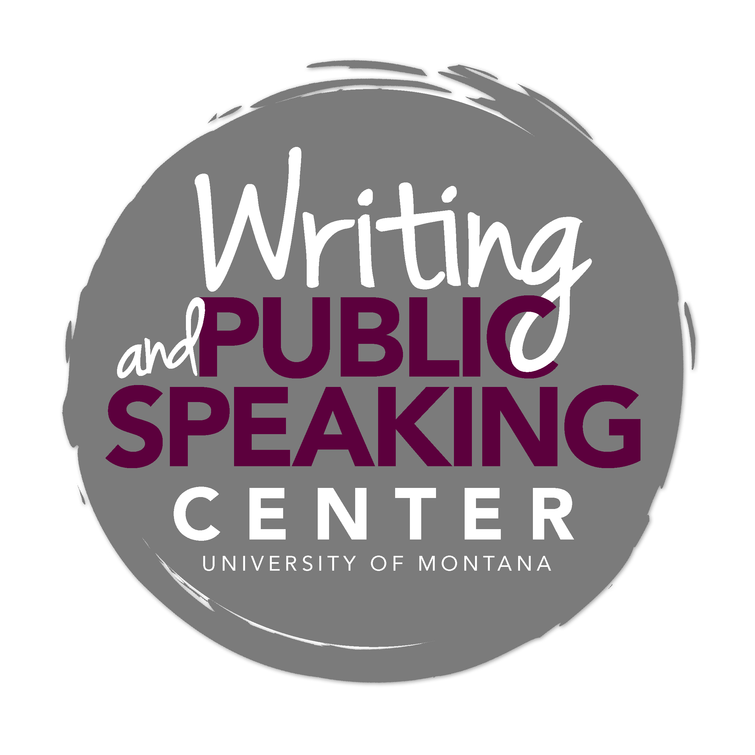
Writing in History

General Advice and Key Characteristics

Taking a Historical Perspective
To think and write as a historian, your descriptions and analyses will derive as much as possible from historical evidence. Taking a historical perspective allows us to understand particular times and places through careful assembly and analysis of evidence considered in historical context rather than present-day terms. By studying primary sources, materials produced during a particular time, or providing direct accounts of events, historians make arguments that teach us something new about the past.

Argumentation and Evidence
Historical analysis is grounded in sound argumentation that seeks to answer not only what happened but also how and why. Opinions and assertions should emerge from a clear line of argument or reasoning based on evidence from primary sources or critical analysis of secondary work. Acceptable secondary sources include peer-reviewed journal articles and books. Writing about history rarely involves explicit exposition of the author’s own general views on politics, morality, human nature, or the like. Similarly, you will not base history papers upon your personal reaction to or experience of reading or viewing a source, but rather upon your analysis of what the source reveals.

Common Writing Tasks

Analytical and Interpretive Essays
Please see the "Analytical and Interpretive Essays for History Courses" resource for detailed guidance.
There are many types of analytical and interpretive essay assignments. In 100- and 200-level courses, professors may ask you to write weekly short response papers based on assigned readings. You may also have take-home essay exams or in-class essay exams. Longer analytical essays are commonly assigned in 200- and 300-level courses.

These analytical assignments usually ask you to make arguments based on primary sources. You might be asked to make arguments about how sources reflect larger social events or processes. For example, “What do Donald J. Raleigh’s interviews with Soviet ‘baby boomers’ reveal about the priorities of the Soviet educational system in the post-war period?” This prompt requires you to use a source (Raleigh’s interviews) to consider social processes (the workings of the state’s educational system) during a particular time (post-war) in a particular place (USSR).

To respond to this sample prompt, you would need to assemble evidence from the interviews, analyze it, and then develop and defend a thesis based on what you have found. Your introduction should include a clear and compelling thesis statement, and each body paragraph should present an idea—often introduced as a topic sentence—that supports this thesis. Support the main idea of each paragraph with carefully selected evidence drawn from the text (i.e., quotes) and with your analysis of this evidence. End your paper with a conclusion that highlights the importance of your thesis.

Primary Source Analysis
Primary source analysis assignments require you to consider a source's limitations and possibilities. Examples of primary sources include letters, artifacts, films, photographs, novels, diaries, memoirs, newspaper articles, and government documents. When analyzing a primary source, ask questions that uncover the conditions of its production. For example why were photos taken in German POW camps during WWI and who took them? Who or what funded the project? What explicit or implicit biases can you identify?

You may be asked to assess multiple primary sources that you have chosen as part of a research project. What can they tell us about your topic? What can they not tell us? How can you best triangulate your different sources (read them in relation to each other) to discern the most accurate understanding possible of your topic?

Annotated Bibliography
Writing an annotated bibliography is an important step in any research project. To write annotations, you must read and think about your sources actively and critically, rather than simply collect information. Preparing an annotated bibliography lets you see what work other scholars have done and where your own research and interpretations fit. By reading and responding to a variety of sources on a topic, you will start to see what the issues are and what people are arguing about, and you'll then be able to develop your own point of view. This will help you come up with a strong thesis.

You will likely be asked to make full citations for your sources, as well as provide a brief summary and critical evaluation of each source. The annotations will usually be about 1-2 paragraphs in length. When annotating books, reading reviews published by other scholars will prove helpful. In general, try to address as much of the following in each annotation.

- Summarize: Who is the author(s)? When/where/why/how was the source produced? What main topics are covered? What are the main arguments? What is the point of this book or article?
- Assess: After summarizing a source, evaluate it. Is it a useful source? What are its limitations? How does it compare with other sources in your bibliography? Is the information reliable? Is this source biased or objective? What is the goal of this source?
- Reflect: Once you've summarized and assessed a source, ask how it fits into your research. Was this source helpful to you? How does it help you shape your argument? How can you use this source in your research project? Has it changed the way you think about your topic?

Literature Review
Literature reviews provide a foundation for research papers, allowing your reader to understand the current state of historiography in a particular area. Assignments may ask you to identify and briefly analyze the major scholarly works you have found to be relevant to your research topic. Situate each of these secondary sources in relation to each other in terms of date and place of publication and contrast them in terms of the kinds of questions they ask, the sources they use, and the different interpretations and arguments they put forward.

Research Paper
Research papers make an informed argument about a particular time and place. You will not merely describe what happened but also develop an explanatory thesis that reveals something consequential about the past. The research process requires a willingness to inquire into a topic without already knowing what you will find out, i.e., without already knowing what conclusion you will reach.

Therefore, research writing requires that you cycle through reading, thinking, and writing tasks that will help you reach a conclusion:
- identify a researchable and sufficiently focused topic for investigation;
- gather information in the form of primary source materials;
- acquaint yourself with the secondary literature so that you can learn what other historians have said about the topic;
- analyze your primary source materials;
- identify a question or problem the source materials help to illuminate;
- formulate an evidence-based conclusion/interpretation that reveals something about the time and place.

Research papers will generally be 15 – 20 pages in length and you will often be asked to use at least 2 primary and 10 secondary sources. Subject Librarians at the Mansfield Library and Writing Center tutors can help you identify and evaluate source materials, narrow your focus, and refine your ideas. Effective research strategies are a key part of a successful writing process.

Film Analysis
Film analysis assignments ask you to consider what a film reveals about a specific time period or theme. Your analysis should reveal what the film says about a particular time period or event (e.g., postwar America or the USSR in the 1920s) as opposed to offer a literary interpretation of what the filmmaker attempted to convey. You will want to take detailed notes when watching the film so that you can refer as specifically as possible to characters, places, scenes and quotes, etc. as evidence when you write your paper.

Critical Review of a Book or Article
Whether you are reviewing a book, multiple books, a selected article, or relevant literature on a particular topic, your task is not only to summarize but also to evaluate in order to identify the strengths and limitations of book(s), article, or set of texts. In the case of a book review or article critique, you must identify the text’s thesis, the methods used, the evidence/data presented, and how it fits into either the historiography of its time or contemporary historiography. Further, you must evaluate how convincingly the book or article accomplishes its purpose.

Historiographic Essay
Historiography is writing about history. The historiographic essay assignment provides an opportunity to develop an argument about how a theme, themes, or topic has been written about or analyzed. Critically assessing historiography can be similar to analyzing primary sources in that you are thinking about the circumstances (e.g., political, intellectual, geographic) in which history was written or is being written. Why were historians engaged in a particular debate during a particular time? Why would a consensus emerge about an interpretation of a particular issue at a particular time?

For example, in a historiographic essay:
- You might ask when and why the Colombian exchange became an aspect of the interpretation of European contact with the Americas. How did the introduction of that concept shift the historiography?
- You might examine how historians have written about women's impact on diplomacy at the Congress of Vienna from the 1920s to the present. Or, you might discuss the ways in which historians periodize the duration of the Vienna settlement. Did it last until 1822? 1853? 1914? What arguments do historians use to support their periodization?

Citation

Your ability to cite without stylistic mistakes is not as important as articulating a focused thesis statement, organizing your paper clearly and logically, and basing your argument on strong evidence. However, citation is vital to making clear where your ideas end and another’s begin; therefore, it is an essential aspect of using and presenting your evidence. Whether you are quoting, summarizing, or paraphrasing in your own words, you must cite your sources. Just like grammar and punctuation errors detract from a strong argument, citation mistakes can make your work seem sloppy.

Most history professors will ask you to use Chicago/Turabian citation style. History 200, Introduction to Historical Research Methods, is required for history majors and covers citation. Professors usually assign either Mary Lynn Rampola's A Pocket Guide to Writing in History or Kate L. Turabian's A Manual for Writers of Research Papers, Dissertations and Theses. If you have not taken History 200 and are enrolled in an upper-division history course that requires you to use Chicago/Turabian style, familiarize yourself with one of the above texts early in the semester and consult the Writing Center or your professor with any questions or concerns.

Common Pitfalls to Avoid

When writing a paper for a history course, take care to avoid the following common pitfalls:

- Errors of anachronism – Take care to place events in the correct order and to rely upon the historical context.
- Presentist judgments – Your task is not to form opinions or judgments based on personal or contemporary values. Rather, your aim is to understand the historical context and to make claims that are supported by the historical evidence.
- Excessive summarizing/lack of analysis – Your task is to move beyond mere summary to help a reader understand your evaluation and analysis of the sources.
- Lack of an adequately complex thesis – A good thesis moves your reader beyond a simple observation. It asserts an arguable perspective that requires some work on your part to demonstrate its validity.
- Lack of adequate support – A well-crafted thesis requires substantiation in the form of acceptable evidence. Often, if your thesis doesn’t make a complex, arguable claim, the act of substantiation becomes difficult. Take care to develop a thesis that will require purposeful use of evidence.
- Use of unreliable electronic sources – Take care to evaluate your sources rigorously, particularly ones from the Internet.
- Use of personal opinion or anecdotes – Personal opinions or anecdotes generally do not qualify as rigorous and appropriate historical evidence in support of a claim.
- Excessive quoting – When quoting a source in order to provide evidence, use only the relevant part of the quotation. When you establish a claim/assertion and provide textual support, be sure to explain the relationship between the quotation and the assertion. Use block quotes and quotes longer than one sentence infrequently. Try to integrate short quoted passages into your own sentences. A good rule of thumb to follow is to include 2-3 sentences of your own analysis for every passage you quote in your paper.
- Improper citation - You need to cite every idea that you did not think up yourself, whether you present the idea in the form of a direct quotation or not. Also, you need to cite each piece of information in your paper that is not common knowledge.
- Use of the first person singular - Rarely is it appropriate or effective in a history paper to begin a sentence with “I think that,” “I feel that,” or “It seems to me that. . .” This essay is written by you, the author, so, of course, it expresses your understandings, interpretations, and thoughts about a given subject.
- Shifting verb tense – Take care to shift verb tense only when necessary. Generally it is best to discuss sources in the past tense. You would discuss what the Supreme Court decided in the Dred Scott case in the past tense. When arguing what the decision reveals, and discussing what conclusions you are drawing in the present, however, you would use the present tense.
- Passive voice – Use active voice as often as possible. Passive voice obscures agency and makes it difficult to determine who is doing what and to whom at a given time.
  - “The soldiers were ordered to attack the Cheyenne.” (passive)
  - “Colonel Chivington ordered the soldiers to attack the Cheyenne.” (active)
- Reference to the author by his/her first name – It is customary and respectful to refer to the author using his/her last name.

