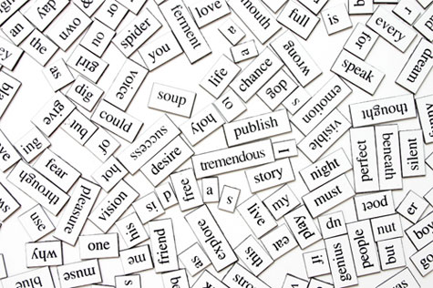Writing Papers for Ways of Knowing
____________________________________________________________________________
What makes a Ways of Knowing paper different?
- WoK assignments require that you use close reading strategies to develop and argue for your perspective on a text or set of texts.
- WoK assignments often ask students to explain how a text challenges a widely held belief or assumption, or how it fits into a broader academic conversation.
- Some WoK assignments invite students to incorporate their personal beliefs or experiences into their arguments. In these assignments, using the “I” pronoun is appropriate.
- Many WoK assignments ask students to compare two or more texts.

What to Look for While Reading
Good writing starts with good reading. Keep a pen in your hand and mark anything you notice that’s surprising, strange, confusing, or beautiful. Also take note of connections you find between the different texts you read over the semester. You don’t always need to have a developed idea about everything you annotate; notes in the margins are a great resource for class discussion and potential paper ideas.

Developing a Strong Thesis Statement
A strong thesis statement presents a claim that a group of intelligent people could debate; in that sense, it’s just a more developed version of an argument you might make in class. In high school, many students learn that a thesis statement should make a point with three reasons, each corresponding to a body paragraph. This technique forms what is known as the five-paragraph essay. In college writing, there is no single formula for a successful thesis statement; it just needs to convey a debatable claim that you can support with textual evidence. This claim should be more than a summary statement and should require some work on your part to demonstrate why it is valid. You don’t need to worry about announcing everything that you will do in the rest of your essay; rather, present the reader with a governing claim that you will develop throughout your argument.

Here are a few examples of strong, debatable thesis statements:

“Although Darwin understood himself as a scientist rather than a philosopher or poet, his Origin of Species flung the poet Tennyson into anxiety and despair, which he attempted to resolve through his poetic explorations of what it means to be human.”

“Rachel Carson’s “A Fable for Tomorrow” does not explicitly invoke Genesis, but its imagery presents a despoiled Garden of Eden in which humans today occupy the role of Adam and Eve, both complicit in and the victims of paradise’s destruction.”

Comparison Essays
Many successful comparison essays examine how one text influenced another, or how one text reacts against another one. For instance, you could examine how the poet Tennyson both resists and embraces aspects of Darwin’s The Origin of Species. Another type of comparison essay uses one text as a critical lens onto another text. For instance, you could use Hannah Arendt’s “Truth and Politics” to help understand the power structures in a Shakespeare play. A comparison essay should not simply describe the differences and similarities between two texts; rather, the comparison should show a relationship between the texts and support an analytical claim (the thesis).

Common Pitfalls to Avoid

“Since the dawn of time” introductions:
Opening statements like “throughout history” or “it is human nature to…” promise more than a short essay can deliver. Begin your introduction with a sentence that focuses your essay: for example, “The protagonists of Sophocles’s Oediupus Rex and Shakespeare’s Hamlet both unwillingly confront the unpleasant matter of their mothers’ sex lives” or “Despite their overtly different attitudes towards divinity and human origins, Wordsworth and Darwin deploy similar nature imagery.”

“I think/believe” statements:
Your essay should always convey your opinion, but you don’t need to hide behind “I think” or “I believe” to show that you are making a claim. “Genesis asserts place as an essential component of identity” conveys more confidence than “I believe that Genesis treats place as an essential component of identity.” Your personal voice is, however, appropriate when your identity is important to the sentence: for example, “I always considered myself a Jewish atheist.”

Block quotations:
Ask yourself honestly: when you read a page of text that includes block quotations, do you read them? Most people skim them—or skip them altogether. Block quotations, which consist of large chunks of text that are set apart by indentation, are rarely appropriate in short essays, as they are difficult to analyze in depth. Instead of using a block quotation, choose a short (3 lines or fewer) excerpt of the quotation and explain how is representative of a broader pattern in the text.

No quotations:
If your essay does not include textual evidence, you are probably relying on summary and broad generalizations to sustain your argument. It is very difficult to persuade your reader without specific textual evidence that you analyze in depth.

