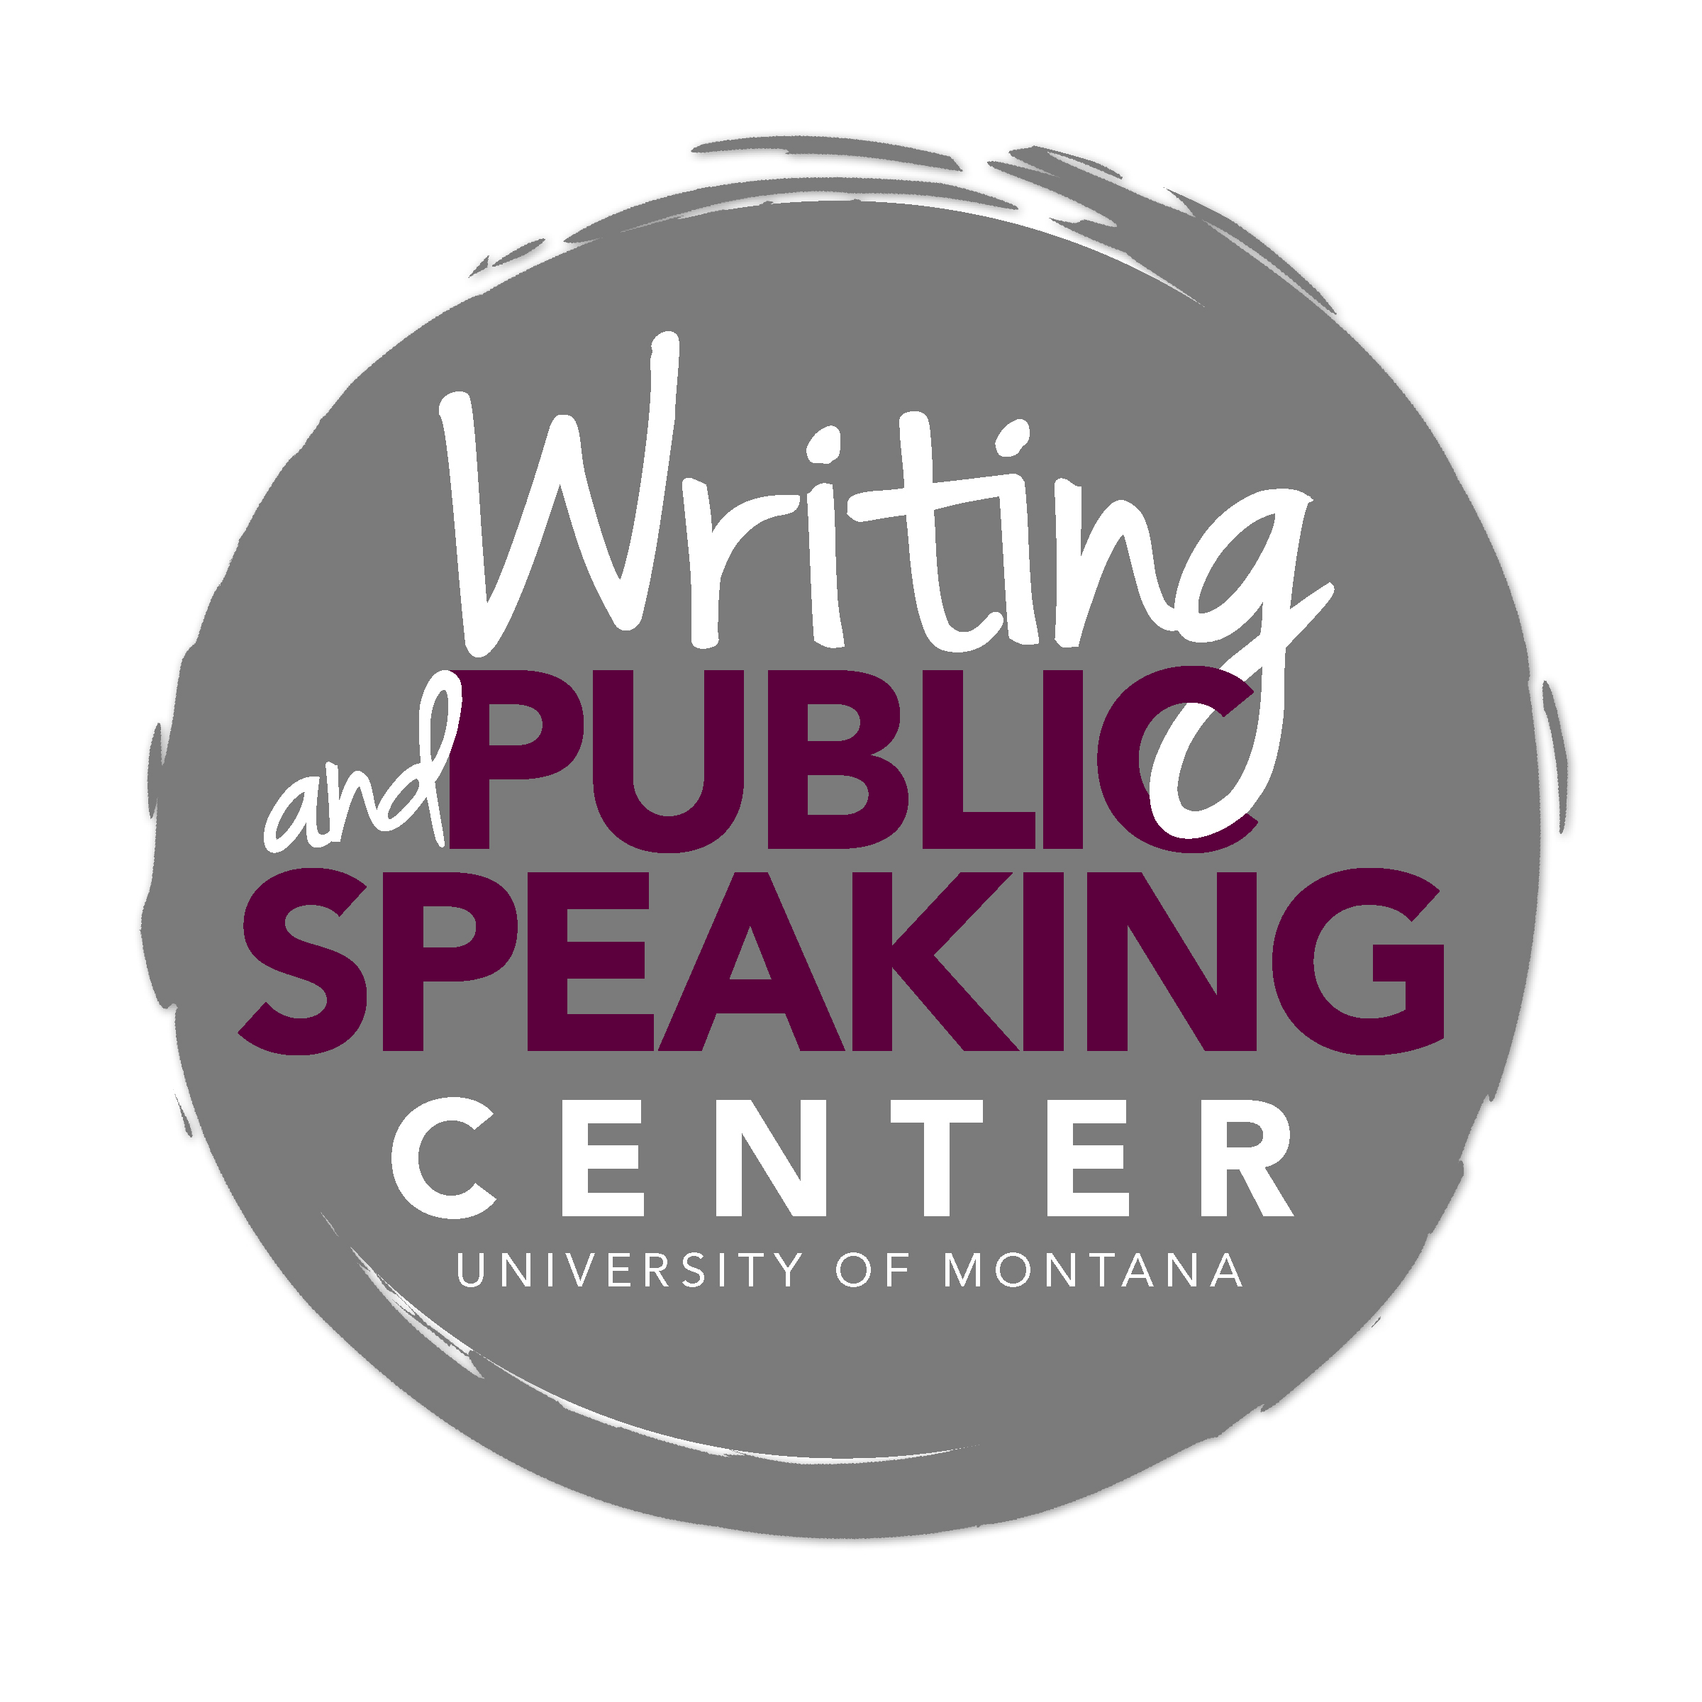

Analytical and Interpretive Essays for History Courses

In many history courses, professors will ask you to write analytical and interpretive essays that rely on the following components. Consider these the primary ingredients for in-class and take-home essay exams, as well as for most essay assignments. Most research papers will also require these elements.

- Thesis: a strong, specific argumentative claim introduced early in your essay
- Evidence: primary and/or secondary sources that support your argument
- Interpretation/analysis: explanations of how the sources support your argument
- Logical Organization: a purposeful ordering of ideas that guides the reader through your argument
- Conclusion: a summary of what you have demonstrated and its broader significance

Assembling these components effectively requires thoughtful preparation and revision. Give yourself as much time as possible to think, draft, and revise.

Writing as a Process: Visualizing the Priorities

Responsiveness means responding to your assignment requirements completely.
- Read the prompt/question carefully.
- Analyze what is being asked of you.
- Identify the different parts of the question.
- Identify the key words.
- Check back in with the assignment requirements as you write.

Then, during your writing process, remember to prioritize the most consequential elements first: the "big picture" aspects such as thesis and evidence, analysis, and organization. After you have addressed these elements, you can then turn your attention to proofreading and editing tasks, taking into consideration grammar and mechanics.
Thesis Statements and the Writing Process
A strong thesis is specific, focused, defensible, stated with conviction, and revised over the course of your writing process. It should be interpretive rather than descriptive. This means providing the reader with not-so-obvious insight about the topic rather than offering a mere description or restatement of information.

Example prompt: Compare and contrast the reasons why the North and South fought the Civil War.

Draft Thesis: The North and South fought the Civil War for many reasons, some of which were the same and some different.
To revise: Examine evidence. Focus on specific reasons.

Revised Thesis: While both sides fought the Civil War over the issue of slavery, the North fought for moral reasons while the South fought to preserve its own institutions. To revise: Write draft of paper. Narrow the focus of your argument.
Final Thesis: While both Northerners and Southerners believed they fought against tyranny and oppression, Northerners focused on the oppression of slaves while Southerners defended their own right to self-government. (Remember: More specific = more persuasive.)

Evidence

Evidence supports your thesis statement. Your thesis statement should be based on careful consideration of the evidence you have assembled. Select the strongest, most relevant facts and examples to explain your claim.

Your evidence will include examples, information, and quotations that support your thesis. Depending on the assignment, evidence can come from lecture notes, course materials, or your own research into primary and secondary source materials.

Evidence Example:

Too general: Stalinist culture glorified the achievements of individual workers.
To revise: find specific information

Revised: During the Stalinist industrialization drive of the 1930s, individual workers were encouraged to
over fulfill their work quotas and received recognition for doing so.

Best: Aleksei Stakhanov serves as an example of the glorification of workers’ achievements under Stalin in the 1930s. After he supposedly moved 102 tons of coal during his shift (14 times his quota), the periodical Pravda featured Stakhanov and he received praise from party officials.

Be sure to cite your evidence!

Analysis/Interpretation

Evidence does not speak for itself. Evidence without analysis and interpretation only amounts to a list of facts or events. Explain to the reader in your own words what meaning to take from a piece of evidence. Your explanation of the evidence tells the reader why a particular quote is important and how it supports your thesis statement.

To avoid presenting a mere narrative/description of events:
- Explain and analyze your examples and facts. What conclusions do you want your reader to draw from them? What do the examples and facts reveal?
- Explain why the example or fact makes your point.
- Explain the connection between the example and your thesis/argument.

Consider the example above concerning Aleksei Stakhanov and the Stakhanovite movement. What if the author simply told the audience that Aleksei Stakhanov moved 102 tons of coal during his shift? Why would we care? Evidence without explanation or interpretation does not move an argument forward.

The author is using the evidence to show that workers’ achievements were glorified under Stalin during the 1930s. The next step is to connect the evidence to the thesis/argument. Let’s say the author’s thesis is: “The glorification of impossible achievements made workers fearful and competitive under Stalinist industrial culture in the 1930s, contributing to the divisive atmosphere that would foster the purges.” How does Aleksei Stakhanov relate to this argument?

The glorification of Aleksei Stakhanov for an impossible achievement, staged by factory officials, reveals that the Stakhanovite movement was based upon impossible expectations. The average factory worker’s inability to perform the heroic feats applauded by newspapers and party leaders contributed to the accusations of “wrecking” that would lead to ostracism and even execution.

Analysis is where the author most clearly shows her/his mind at work.

Organizing your essay = Organizing your argument

Structure your essay by organizing the main points in your argument.
- Ask yourself: In order to understand the validity of my thesis statement, what does my reader need to know first? second? third? fourth? etc.
- For each point, pick the most effective supporting evidence.
- Try writing topic sentences to state the main point for each paragraph.
- Explain the connection between your examples and your thesis/argument.
- Try producing an outline of your draft to assess whether you have organized your ideas logically.

Introduction
The essay must begin with an introductory paragraph that explains to the reader what the paper is about (topic) and clearly expresses your main claim (thesis statement). The main claim should be stated in the introduction so that the reader can assess its validity while reading the body of the essay.

Body Paragraphs
In the body of the essay, you will convince the reader that your thesis is valid. These body paragraphs present your relevant evidence and your analysis of the evidence.

The paragraph is the fundamental building block of an essay. Every paragraph in your paper should develop one coherent point that advances your argument. Each paragraph should begin with a clear statement of the point you want to convey. It should continue with several sentences that contain evidence and analysis supporting the point. The paragraph should conclude with an explanation of the significance of the point developed in the paragraph or of its relationship to the rest of the essay. Including these components in your paragraphs will help to ensure your essay is compelling and persuasive.
Conclusion
The conclusion should not simply restate your thesis. Rather, it should try to attach larger significance to your main claim. How does your argument connect with larger historical themes or developments?

Revision

Few writers get away with producing one draft of their essays or one version of their thesis statements. Skilled writers modify/refine a thesis statement after writing the first draft of the essay.
- Take note as your thinking becomes more sophisticated and insightful during your writing process. Writing is a tool not only for communicating but also for thinking.
- Use that more sophisticated and insightful thinking to refine your thesis statement. Look over your primary sources and lecture notes again. Have you assembled the best evidence to support your argument?
- Revise and edit the paper as a whole so that it flows smoothly, is written clearly, and contains no typographical errors or grammatical errors.

Habits that lead to successful exam and essay writing

- Keep up with readings and lecture notes.
- Analyze the readings to understand the what, why, and how of a time period or event.
- Identify themes in course materials.
- When possible, ask someone to read your work to get a sense for whether you’ve presented a convincing argument whose logic is clear to a reader.

“Thesis Statements,” The Writing Center, University of North Carolina at Chapel Hill, https://writingcenter.unc.edu/handouts/thesis-statements/ (accessed February 4, 2014).

