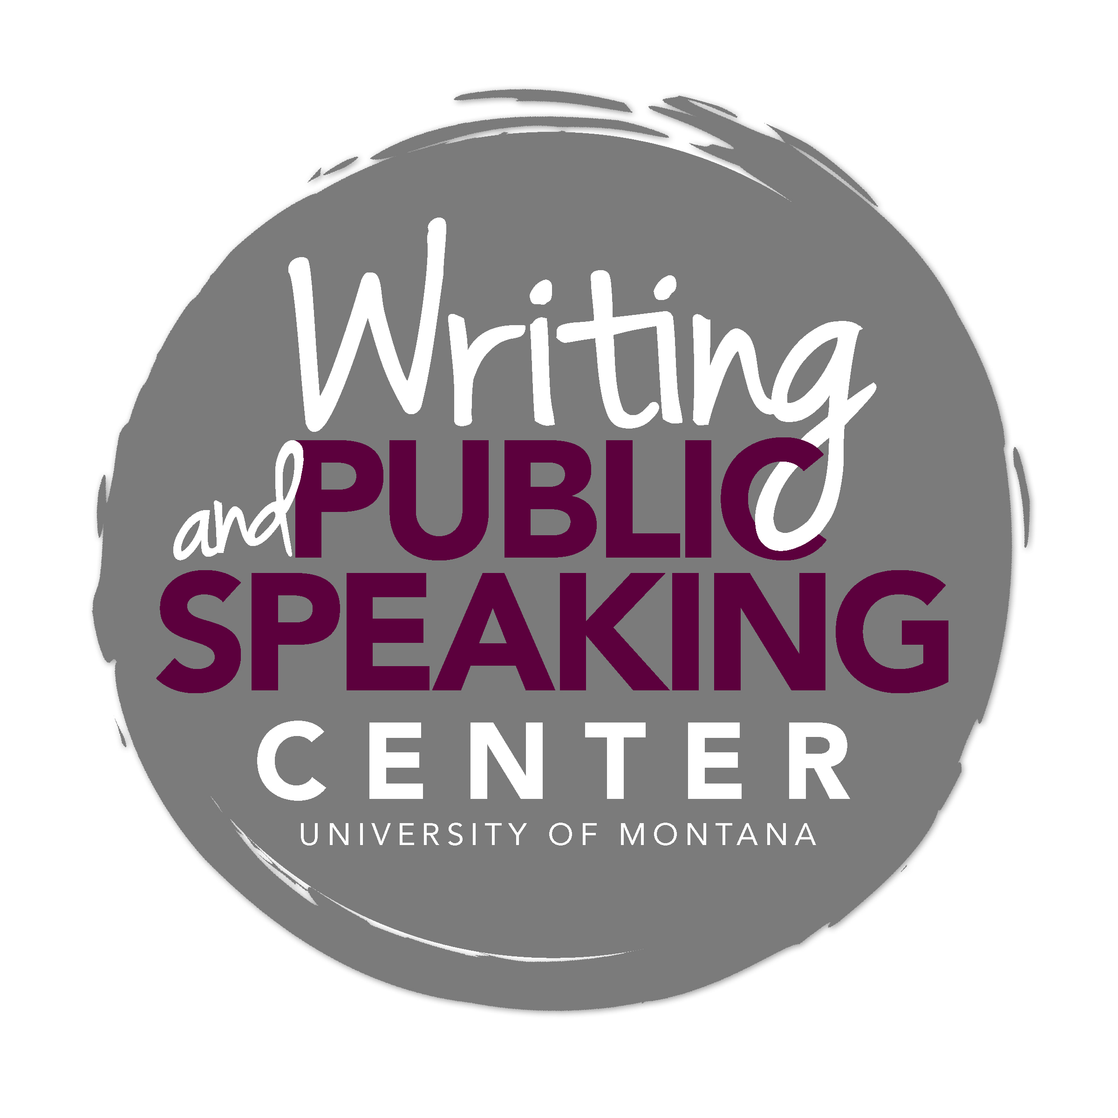

Communicating in Wildlife Biology

General Advice and Key Characteristics

A Wildlife Biologist’s Approach to Communicating
Wildlife biologists describe the natural world, make management recommendations, and support claims with robust evidence. They begin research with a strong theoretical grounding, develop clear objectives and hypotheses, and discuss the implications of their results for regional or global wildlife management. One of the wildlife biologist’s most difficult charges is to use models to predict how wildlife will behave under changing biotic and abiotic conditions. Wildlife biologists must be realistic about the claims they make and the certainty of their findings. Hypotheses are never proven; evidence merely supports hypotheses (or not).

Writing in wildlife biology contributes to ongoing conversations among scientists and other interested stakeholders. A newcomer joins this conversation by becoming familiar with the literature, following citation trails, and eventually adding new findings to the discussion. Wildlife biologists explain their thinking and findings, allowing new scientists to enter and understand the conversation. Wildlife biologists also communicate their findings to non-expert audiences.

Ask These Questions
No matter your writing task, clearly answer these questions:

- What did I ask?
- What should the reader learn?
- Why should the reader care?

Know Your Audience
Wildlife biologists communicate their work to all kinds of people, from fellow scientists and wildlife managers to concerned citizens and elementary school students. By identifying your audience, you can adjust the tone, vocabulary, and structure of your writing to fit the audience’s needs. Think about the audience’s expectations and level of familiarity with the topic. While making choices appropriate to the audience, wildlife biologists maintain credibility across audiences by remaining objective in their research and in their communications.

Tell a Story
Just because wildlife biologists rarely write fiction doesn’t mean they do not tell stories. Regardless of the intended audience, presenting scientific findings as a story helps the audience remember key points and remain engaged. Identify the main characters (which may be elk, gut flora, or oil platforms) and structure paragraphs chronologically around their actions, moving from the general to the specific. Your story should have a “moral” or take-away point that relates to the improvement of wildlife populations or that provides theoretical support for management actions.

Aim for Clarity
A wildlife biologist’s task is to produce clear writing that helps the reader understand the science. Avoid jargon, unnecessarily long sentences and paragraphs, confusing acronyms, and any other writing practices that may confuse the reader. Don’t try to impress. Instead, use straightforward prose to reveal the quality of your scientific thinking.

Common Writing Tasks in Wildlife Biology

Annotated Bibliography
An annotated bibliography is a list of peer-reviewed articles about a specific topic. Each citation includes a brief critical description of the study. The annotation should both summarize and evaluate the quality of the source, compare the study to other works in the bibliography, and explain the study’s unique contribution. An annotated bibliography helps you compile and understand relevant sources that you may eventually synthesize into a literature review. This writing task can also be a first step toward developing a research question and identifying methods others have used to address similar questions.

Literature Review/Synthesis
The literature review serves either as a tool to develop your own research question or as a standalone synthesis of existing knowledge. After selecting a topic, summarize the current state of research; evaluate the quality of the sources; recognize where experts disagree, agree, or build upon one another’s ideas; and identify areas for further inquiry. Although more recent publications (from the last 5-10 years) are preferable, foundational papers in the field can also help you develop your argument. Simple summary won’t be sufficient – you must highlight relationships between the texts and synthesize the findings of various authors to tell a cogent story. A thorough literature review can help you identify a research question that, once answered, contributes new information to the existing literature.

Abstract
An abstract is a short (250-500 words) summary of an academic paper or proposal. Write the abstract after you complete your paper. Readers often decide whether the article is worth reading based on the contents of the abstract, so the abstract must capture attention as well as accurately reflect the paper’s focus. The abstract should include: 1) the problem studied or hypothesis tested, 2) the most pertinent methods used, 3) the most important results generated, and 4) the utility of results for science or management. The abstract should contain original language, so refrain from copying and pasting sentences from the full paper.

Research Proposal
Research proposals outline plans for a future project. Your task in writing the proposal is to convince the audience that the proposed research is achievable and worth conducting. The research proposal clarifies the purpose of the project, dives deeper into the existing literature, and reduces the scope of the question for feasibility. You may write a proposal for a grant or scholarship, or to obtain approval from a university committee, NGO, or government agency. Exact guidelines vary, so read these carefully. A typical research proposal includes an in-depth introduction and background, clearly stated hypotheses and/or predictions, listed objectives, methodology, expected results, implications, potential challenges (and strategies for meeting these), and a timeline for completion.

Journal Article
A journal article describes the process and results of a completed research project and is intended for publication in an academic journal such as Wildlife Management. These journals are widely distributed to scientists in the field and have a formal tone that assumes some level of familiarity with the subject beyond what a general audience would know. This does not mean that an article should be wordy or abstruse; the goal is to present clearly your findings. Avoid jargon and define key terms, especially those related to any measured variable. Readers may skim the paragraphs and spend the most time examining figures, so make sure these figures and their captions are easy to understand.

The article’s structure will vary depending on the journal. Read the journal’s guidelines and browse a past issue of the journal to become familiar with the content and tone of a typical article. Most journal articles have a structure similar to a research proposal, with a few key differences. Below are a few general guidelines for writing a research article:
- Introduction/background
- State the problem
- Provide enough background so that a reader unfamiliar with the issue can understand your findings
- Define technical terms
- State the research question/hypotheses
- Methods
- Describe the study area (if applicable)
- Include sampling techniques, duration, research or experimental design, and statistical analyses used
- Use active voice (use “we vortexed samples” instead of “samples were vortexed”)
- Include ethics/animal welfare statement, if needed
- Results
- Provide statistical evidence in support of the results
- Include visual representations (graphs, charts, and figures)
- Present data (remember that interpretations of data belong in the discussion)
- Discussion
- Interpret results and discuss implications
- Identify new questions the findings raise, and specify future research directions

Management Plan
Because wildlife biology is an applied science, writers usually outline the implications of their findings for management and agencies. Management plans are specific to species, ecosystems, or management areas, and typically use data and modeling to recommend quantitative and qualitative objectives for wildlife within an area. The objectives can include ideal population size, harvest quota/limits, disease prevention, and reduction of human-wildlife conflict (among many others). These objectives must respect existing regulatory and policy restrictions. In addition, management plans should suggest concrete actions to meet specific management objectives. Although these plans primarily inform wildlife managers who have a strong background in the field, they are also pertinent to other government officials, politicians, and the public. Therefore, keep your audience in mind as you write.

White Paper
Scientists and managers develop white papers to explore issues important to wildlife decision makers. The audience therefore consists of educated, non-expert legislators and/or administrators. A white paper should summarize findings from one or more studies, identify conservation challenges and priorities, and make management recommendations. While species conservation is the ultimate goal, scientists and managers should determine the appropriate methods to engage different wildlife stakeholders (landowners, industry, livestock owners, consumptive users, etc.).

Presentations
Wildlife biologists must be effective written and oral communicators, and should be able to prepare presentations that are appropriate for specific audiences. Typical presentations in wildlife biology include:

- Elevator Speech
An elevator speech is a 60-90 second talk that succinctly conveys a message about you or your work. These speeches are appropriate for informal networking settings. Have an elevator speech ready when you attend a professional conference, job fair, Thanksgiving dinner with relatives, or anywhere else you’re likely to meet people interested in your work. Practice your elevator speech so that you hit the key points, but refrain from memorizing it; the speech should sound natural and conversational.

- Talks
Wildlife biologists prepare longer talks (15-45 minutes) for a variety of occasions, including proposal and dissertation defenses, professional conferences, symposia, and outreach events. The style and structure of these talks vary depending on the topic, audience, and allotted time. However, following a few general guidelines will improve your talk:
- Your audience won’t be able to go back and review your points. Therefore, you should structure your talk around a few take-home messages that your audience will remember.
- The best talks are mostly visual. Forgo lengthy chunks of texts in favor of figures that illustrate your speech. If your slides include long paragraphs, your audience will likely read rather than listen.
- Rather than reciting or memorizing, practice your talk until it seems natural. Reading from notes sounds stilted and will bore the audience. If you are concerned about forgetting talking points, include one or two keywords per slide to trigger your memory.
- Stick to a simple PowerPoint theme with a professional font choice and no unnecessary animations.
- Enthusiasm is contagious! Let your natural interest in the topic shine through your demeanor and tone.

- Commission Meetings
Wildlife Commissioners are the decision-making authorities on wildlife management in a state. They receive management recommendations from state Fish and Wildlife agencies, biologists, and the public, and then make regulatory decisions. When making a presentation before the Commission, your task is to convince them of a position on a wildlife issue, which may be controversial.
- Tailor the presentation to the audience. In Montana, the Fish and Wildlife Commission is composed of five citizens with a general interest in the management of wildlife, but not necessarily with formal biological training. At least one member must represent the interests of livestock owners, and members of the public often attend Commission meetings.
- Provide sufficient background information in case the Commissioners are unfamiliar with the issue.
- Cite any relevant statutes and regulations.
- Be prepared to answer difficult questions. Commissioners may interrupt your presentation if they need clarification on the issue.
- Explain the biological and social implications of the position you are espousing. Human attitudes and values are important factors in wildlife decision making.

Common Moves for Writers in Wildlife Biology

Reviewing Peer Work
Articles in reputable scientific journals undergo peer review before appearing in print. The peer review process ensures that journals publish studies with sound methodology and reasonable conclusions. You may occasionally use your expertise in wildlife biology to critique one of your peer’s papers. Good peer reviewers offer constructive yet respectful feedback focusing on viability of study design, appropriateness of chosen methodology and statistical analyses, and logical relationships between presented data and conclusions.

Synthesis of Prior Literature
To synthesize existing literature, move beyond summary and analyze the relationships among evidence and concepts presented in the literature. The focus of synthesis is not on individual sources but rather on the larger concepts, conclusions, and approaches those sources highlight. Google Scholar provides a powerful search engine that allows you to see source “trees” linking articles that have cited one another. You can access most major wildlife biology journals through the UM library databases.

Developing an Original Research Question
Start this process by choosing a topic and familiarizing yourself with the subject. Read relevant books and reviews that synthesize existing information. Then, conduct a thorough literature review of your own, identifying gaps in the literature, and determining potential directions for future research. Narrow your focus to a single inquiry. Coming up with a truly novel question is one of the most difficult leaps that wildlife biology students must make, but reading plenty of related literature with a critical eye will improve your ability to design innovative research questions in response to current needs.

Revising Work
Revision doesn’t just mean correcting grammatical errors. The best papers are substantively revised multiple times. When revising, look for awkward phrasing, imprecise word choice, redundancy, long-windedness, and disorganization. Read your paper out loud to catch gaps in content, clumsy sentences and mistakes, and unfocused sections. Ask others (experts and non-experts) to review it as well. Reverse outlines (outlining your paper after you’ve written it) can help you determine the most logical way to reorganize your paragraphs.

Learning Academic Citation and Formatting Styles
Each journal in the field has unique format and citation requirements. Common citation styles in wildlife biology include American Psychological Association (APA), Council of Biology Editors (CBE) and Modern Language Association (MLA). Most journals prefer in-text parenthetical citations that include the authors’ last names and year published, but some require footnotes. Using reference management tools like RefWorks, Mendeley, and/or EndNote will reduce error (and your personal suffering) throughout this process.

Distinguishing Original Thought from Paraphrase
Wildlife biologists often summarize and synthesize other scientists’ findings. Becoming adept at succinct paraphrase, or restatement of another’s words without losing nuance, is key to writing in wildlife biology. Citations inform the reader that the thought is not your own and allow the reader to trace ideas back to the original author.

Evaluating Quality of Sources
Recent peer-reviewed academic articles are optimal, but you should evaluate articles published in even the most “prestigious” journals. News articles, technical reports, and government publications (“grey literature”) can be acceptable depending on the context, but you should evaluate these with even more skepticism. Websites and blogs are generally not appropriate. Question whether the author is likely to be providing unbiased, accurate, and timely information. Cite all sources regardless of origin.

Using Figures to Illustrate your Findings
Scientists use figures (tables, graphs, charts, and other visuals) to synthesize and present large amounts of data for the reader’s quick understanding. Figures can also be useful outside of data summary; for example, concept maps synthesize abstract ideas for better comprehension. Figures should include as little white space and as few colors as possible, and should be well labeled with a main title, axis labels, and a symbol key if needed.

Some Tips

Questions to Ask of Your Draft
As you write and receive feedback on your papers and presentations, consider asking the following questions:
- What is my research question (if applicable), and why should we pursue this line of inquiry? Take time to answer these questions before you write.
- Does each word contribute something to this sentence? If not, cut, condense, and rephrase. Scientific findings can be difficult to understand, so reduce confusion and misunderstanding by avoiding wordy constructions.
- Does my writing sound monotonous? If your writing sounds boring when recited out loud, it is probably boring to readers. Try varying your sentence lengths and adding transition words (“however”, “in addition”, “nevertheless”) to guide the reader smoothly through your piece.

Pitfalls to Avoid
- Long strings of abstract nouns (“the distinct population segment project review”)
- Overuse of “to be” verbs – use more specific verbs for concise and lively prose (use “mortality rates differ” instead of “mortality rates are different”)
- Placing the main subject and verb of the sentence far away from each other
- Passive voice (use the active “scrub jays began breeding in April” instead of “breeding was begun in April”)
- Unnecessary quoting – paraphrase unless the quotation is particularly well-put or unless the way something was worded matters
- Jargon and pseudo-scientific terms when simpler words will do (use “use” instead of “utilize”)
- Mixing up the words “affect” (a verb) and “effect” (usually a noun)

Useful Resources
Brigham, M. R. 2010. “Talking the talk: giving oral presentations about mammals for colleagues and general audiences.”
Journal of Mammalogy 91(2): 285-292.
Greene, A. E. Writing Science in Plain English. 2013. The University of Chicago Press, Chicago, IL.
Janzen, D. 1980. “Plea from a Symposium Goer.” Bulletin of the Ecological Society of America 61:170-171.
Mesmer, T.A., & Morrison, M.L. 2006. “Unified Manuscript Guidelines for The Wildlife Society Peer-Reviewed
Publications.” The Journal of Wildlife Management 70(1): 304-320.
Rolandi, M., Cheng, K., and Perez-Kriz, S. 2011. “A Brief Guide to Designing Effective Figures for the Scientific Paper.” Advanced Materials 23: 4343-4346.
Sand-Jensen, K. 2007. “How to write consistently boring scientific literature.” Oikos 116: 723-727.
Science. 2016. From Good to Great: Five Tips That Will Make You a Great Peer Reviewer. American Association for the
Advancement of Science

