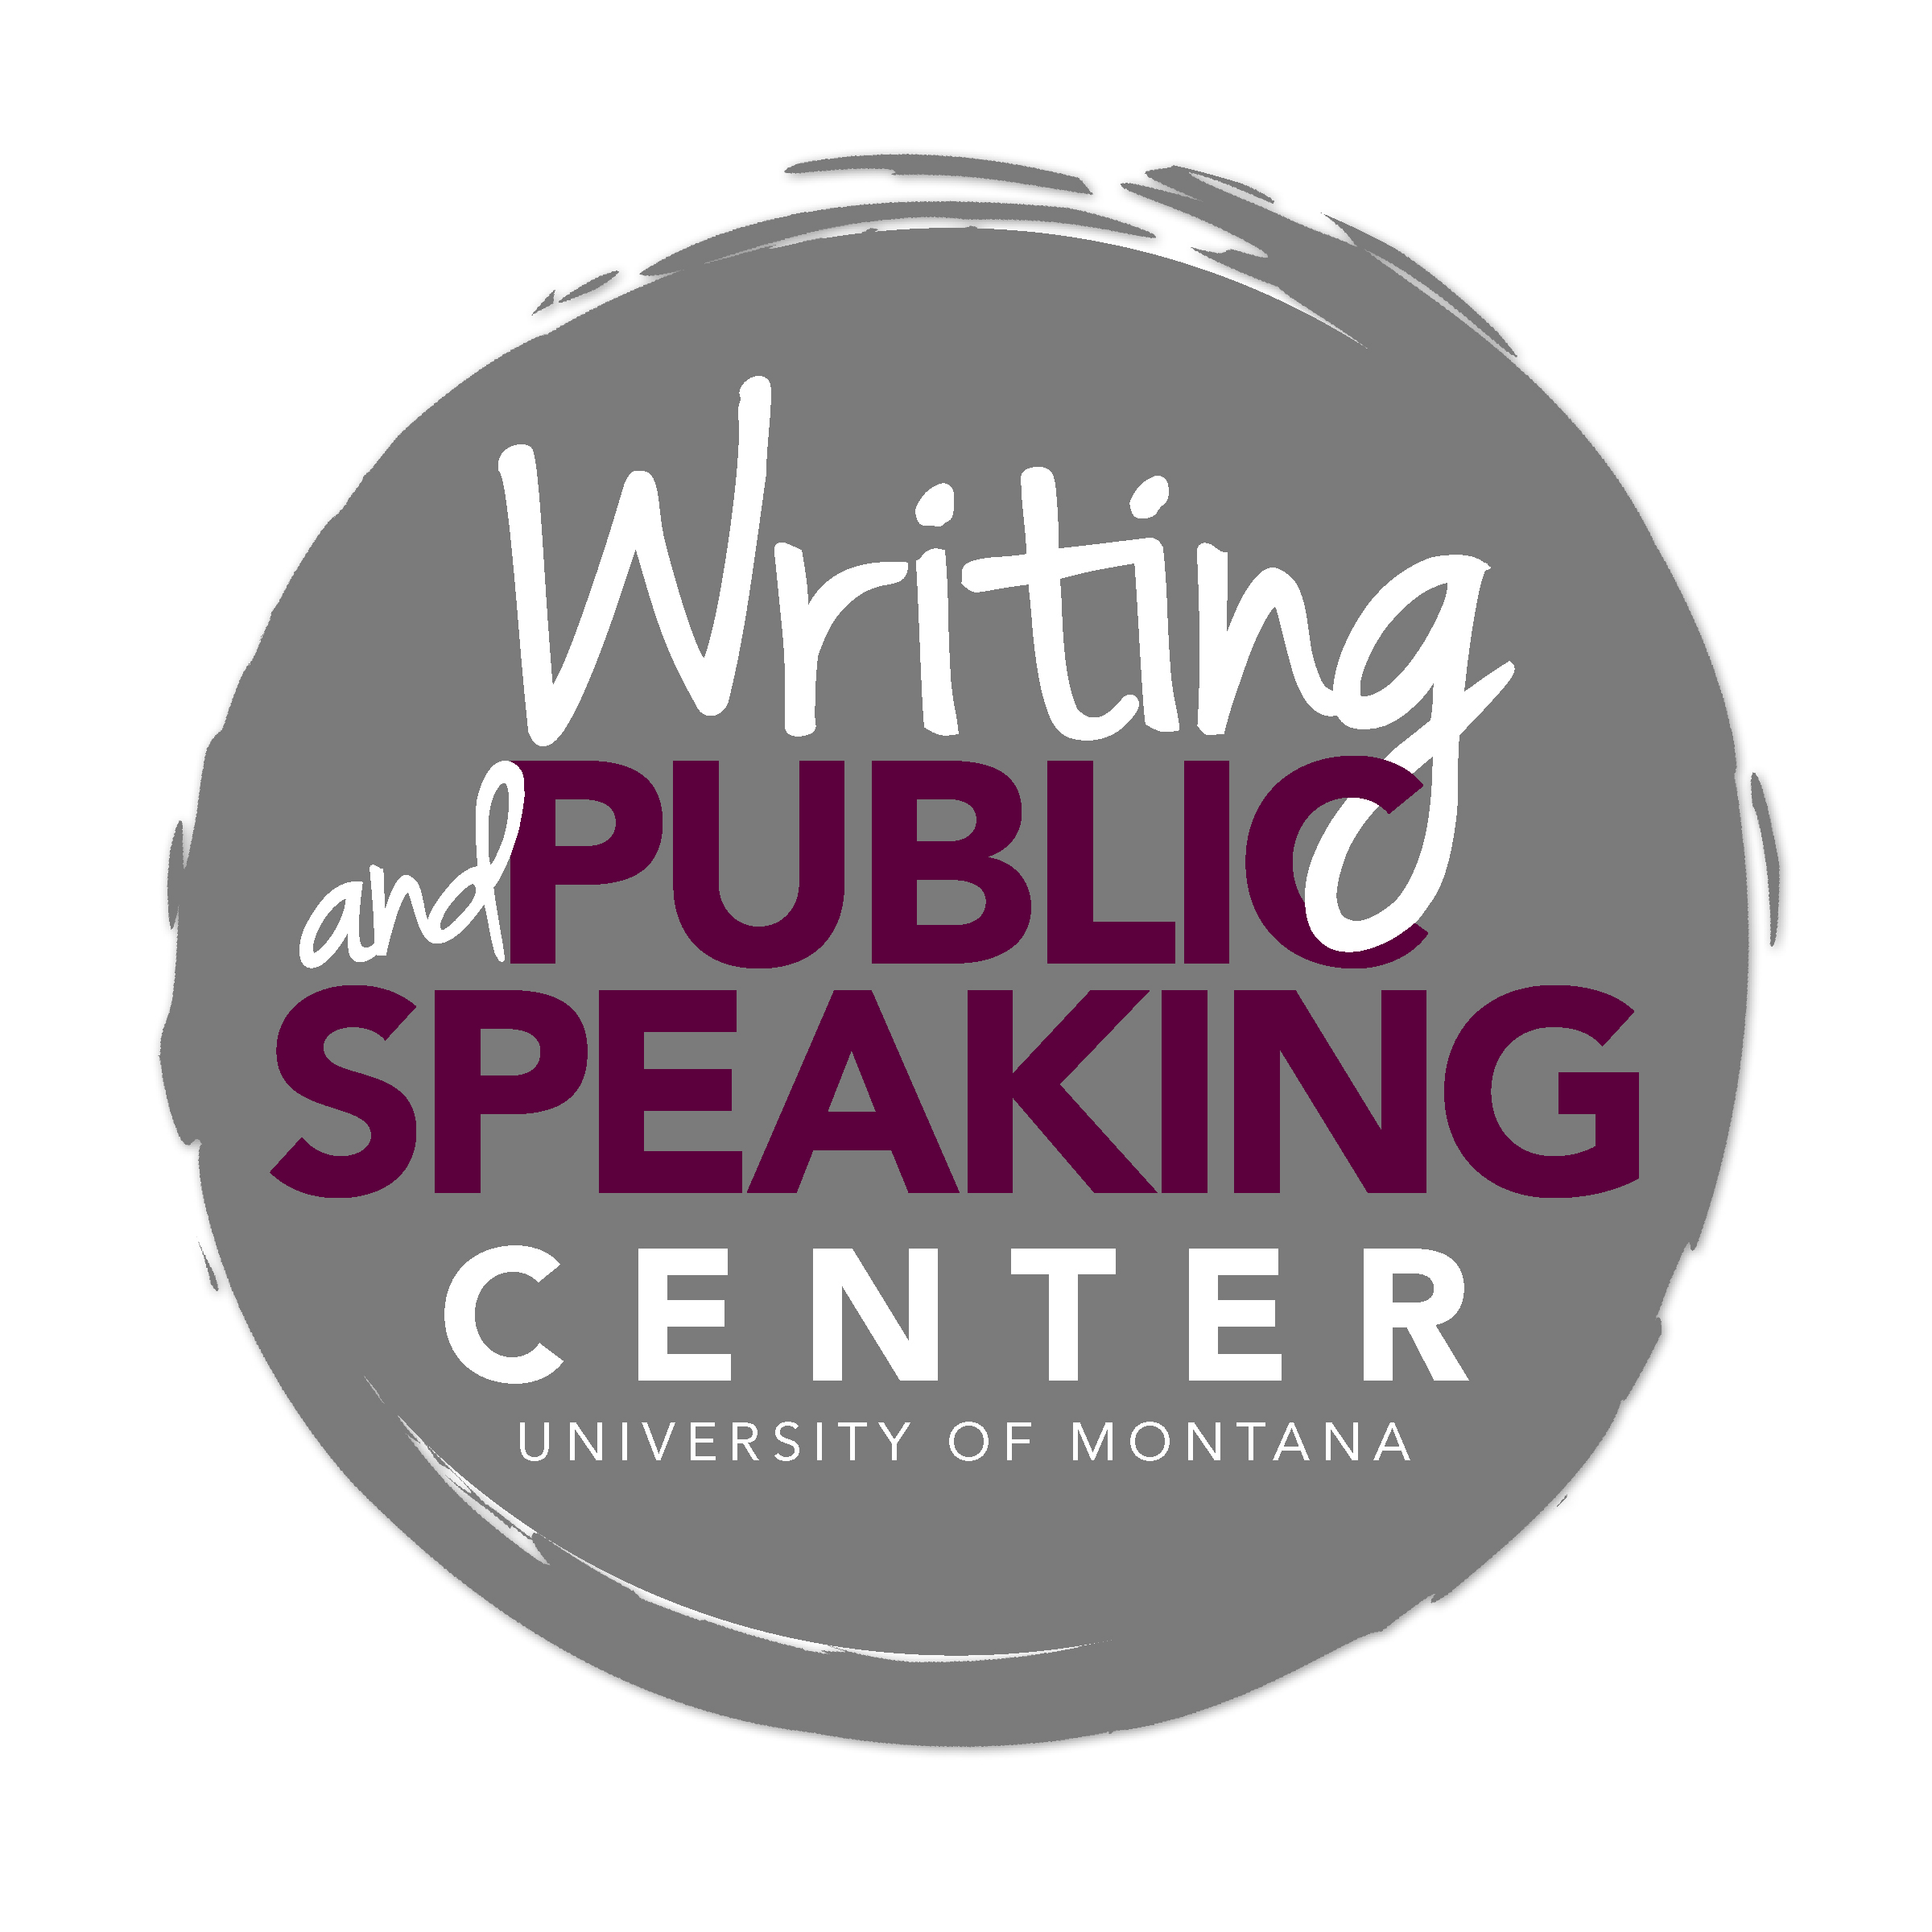
Writing in Accounting and Finance

General Advice and Key Characteristics

Written Communication in Accounting and Finance
Companies value effective business writing, a fact evidenced by employer screenings and formal examinations that evaluate candidates’ writing skills. Understanding how to apply general accounting principles and laws, and finance theories and tools is critical but not sufficient. Employers recognize that “the major differences among competitors may often be found in the degree their employees have mastered writing, speaking, and other non-technical skills”. Accounting and finance professionals spend significant time writing to document the results of analysis, research, and procedures performed. A well-executed analysis loses its value when not effectively summarized and communicated in a document.

Characteristics of Successful Writing in Accounting and Finance
- Audience awareness – the writing targets and is tailored for the appropriate audience
- Clear purpose – the writing serves a clear purpose (e.g., to inform, to argue, to recommend)
- Accurate content – the writing includes only accurate and timely information
- Conciseness and clarity – the writing presents information concisely and clearly
- Effective organization – the writing organizes information for readability
- Appropriate format – the writing follows the specific guidelines for the type of document required
- Polish – the writing is polished and error free

Analysis and Evaluation Grounded in Evidence
Writing tasks in accounting and finance professions often require you to move beyond summary of information to analyze and evaluate a scenario or data. Your analysis and evaluation should lead you to draw conclusions or make recommendations grounded in documented and carefully collected evidence. For each claim you make, ask yourself, “how do I know this?” This is especially important in widely-reviewed auditing documents that present evidence supporting your firm’s audit opinion.

For example:
- When making a recommendation regarding a company’s plans to move into a new market, you must ground your recommendation in proper analysis of the financial data.
- When writing a memo informing a small business client of a serious internal control weakness, you must evaluate the situation in terms of the potential audit and asset protection consequences.

Take care to distinguish between your opinion and evidence that is grounded in what a text actually says or in what the data actually tell you. Be rigorous in making this distinction. Clearly express an evidence-based conclusion when analyzing data for compliance or reasonableness.

Conciseness
Effective writers in accounting and finance professions make their points using as few words as possible. Make careful decisions about which ideas to include and omit, avoid wordiness, and choose words that precisely represent your ideas. Do not waste your reader’s time.

Common Writing Tasks
While each of the following types of writing requires a specific format, all should adhere to the characteristics of successful writing listed above.

Memos and Emails
Memos (memorandums) generally are a means for internal communication, e.g., between accountants and clients or between departments. Memos are often used to summarize a professional conclusion that aligns with required standards and procedures. Be sure to cite relevant authoritative sources as support for your conclusion. Because e-mail often serves as the preferred mode of communication, the guidelines for effective memo communication apply to e-mail as well. Keep memos and emails concise, presenting the most important information near the beginning of the document. Emails should include a descriptive, strong subject line. Beware: memos and emails become official documents that may be referenced at a later date and by readers other than your original audience.

Letters
Letters allow professionals to build relationships, respond to requests, make recommendations, to initiate actions. Accountants and finance professionals write letters to multiple recipients such as clients, colleagues, and government agencies. Like memos and emails, a letter becomes an official document that may be referenced at a later date and by readers other than your original audience. Professional standards or firm practices may dictate the format and content of some letters.

Tailor each letter to the specific needs of the primary recipient:
- Strike the tone that will make the reader feel the way you intend.
- Provide enough detailed information to help the reader understand your message.
- Organize your information into digestible paragraphs that make each key idea clear.

Reports
Accountants and finance professionals produce reports for clients and internal audiences. Usually, reports apply finance or accounting principles to a specific problem or question. Reports often require that the writer engage in research and always require that information be logically organized and sometimes separated into discrete sections. Longer reports should include an executive summary.

For example:
- An accountant working for an internal audit function might produce a report suggesting improvements to a process or internal controls. A finance professional might produce a report for a client who is considering selling her business and who would like information on the various methods of establishing a market value for a private company.

Professional Certification Exams
You will write under timed pressure not only in your accounting and finance courses but also in the context of professional certification exams. This mimics the time pressure experienced in many accounting and finance jobs. For example, CPA and CFA exams may ask you to consider a case study (a “simulation”) and produce a document (a letter, memo, or brief report) in response.

For most of these timed writing situations, you will be evaluated based on the following criteria:
- Responsiveness – address completely the question asked or scenario presented
- Development – provide and discuss appropriate evidence in support of your thesis/answer
- Organization – introduce your thesis/answer, present your ideas in separate paragraphs marked by clear topic sentences, and create smooth transitions between ideas
- Polish – carefully proofread your essay for correct grammar, punctuation, and mechanics

Some of these exam questions are graded primarily on the execution of writing rather than the content of the response. The quality of your ideas is still important; however, ideas presented in a document marred by disorganization, typos, and grammatical mistakes will result in a lower grade on the question.

Other Common Moves

Understand the conventions for the type of document required
In your courses and in the professional world, the writing situation will dictate the type of document you must produce. When writing memos, letters, reports, and other types of documents, refer to example documents to become familiar with accepted conventions and specific formatting guidelines.

Tailor your document to your purpose and audience
Know your purpose and audience. Are you writing to inform, persuade, recommend, or request? To whom are you writing? Your answers to these questions will help you make decisions regarding:
- the type and extent of information to include.
- the most effective way to organize the content.
- the type of language and tone most appropriate for the writing situation.

Use graphic information purposefully
Tables and figures (graphs and flowcharts) can be a useful way to summarize key information. However, take care to make purposeful decisions about which information needs to be presented visually, then present precisely and in a simplified form. Be clear. Be brief. Describe these visuals in the text, explaining the main point and significance of the information presented.

Document sources accurately and ethically
Make clear where your ideas end and another’s begin. Whether you are quoting, summarizing, or paraphrasing in your own words, you must cite your sources. Even if you do not intend to plagiarize, if you do not properly cite your sources, you have plagiarized. Chicago Style is a commonly used documentation system that allows writers to document consistently those aspects of source materials that most matter to the discipline. Refer to The Chicago Manual of Style, 16th edition.

For example, even information from the Financial Accounting Standards Board’s Accounting Standards CodificationTM and from the United Sates Securities and Exchange Commission must properly be documented.

Due to the unique regulatory environment in these professions, regulators frequently review documents accounting and finance professionals generate. Inaccuracies or confusing documentation can have negative consequences for your employer.

Some Tips

Questions to Ask of Your Draft
As you write and receive feedback on your papers, consider asking the following questions (not all questions are applicable to all types of assignments):

- Do I respond to the assignment? Do I summarize when I’ve been asked to analyze, evaluate, or recommend? Do I recommend when I’ve been asked only to inform?
- Does my writing follow the proper conventions for the type of document specified (letter, memo, report, etc.)?
- Do I strike the appropriate tone for the audience and situation? Do I use professional rather than casual language?
- How do I know my claims are true? Do I use evidence that is grounded in my analysis of the data and in professional standards rather than in personal experience? Do I cite the authoritative literature?
- Does my document have a meaningful organization that breaks my ideas into logically organized paragraphs and purposefully moves a reader from one idea to the next?
- Do I waste space on excessive summary of sources? Do I make purposeful choices about when to summarize, paraphrase, and quote sources?
- Do I effectively use tables and charts to summarize complex data or findings?
- Do I distinguish my ideas from those of the authors/theories/articles I discuss?
- Have I carefully proofread my document to eliminate confusing sentences, grammatical mistakes, punctuation errors, and typos?

Common Pitfalls to Avoid
When writing a paper for an accounting or finance course, take care to avoid the following:

- Improper use of a theory or principle– If you are applying a particular accounting or finance principle, be sure you have a good understanding of this principle.
- Failure to address the assignment – Be sure to write in response to the question asked, the problem posed, or the scenario provided.
- Excessive summarizing/lack of analysis – If your task is to evaluate and analyze data, simply summarizing the information will not be adequate.
- Lack of adequate support – Provide and explain evidence that shows you have analyzed the data and applied the appropriate professional principles. Cite authoritative standards, laws, and rules supporting your conclusion or recommendation.
- Use of personal opinion or anecdotes – Personal opinions or anecdotes generally do not qualify as rigorous and appropriate evidence in support of a claim. Your opinion does not qualify as data.
- Lack of an adequately complex thesis – For essay assignments, a good thesis moves your reader beyond a simple observation. It asserts an arguable perspective that requires some work on your part to demonstrate its validity.
- Inappropriate tone and language – An effective business document is tailored to the purpose and audience at hand.
- Use of unreliable electronic sources – Take care to rigorously evaluate your sources, particularly ones from the Internet. Ask who authored the information, who published or sponsored the information, how well the information reflects the author’s knowledge of the field, and whether the information is accurate and timely.
- Excessive quoting – When quoting a source in order to provide evidence, use only the relevant part of the quotation. When you establish a claim/assertion and provide textual support, be sure to explain the relationship between the quotation and the assertion.
- Wordiness – Be as concise as possible without omitting important content. Frequently, the task is to summarize facts or compare data to a standard rather than to write endlessly about a situation.
- Plagiarism – Plagiarism is the use of someone else’s work or ideas, in any form, without proper acknowledgement. Whether you are quoting, summarize, or paraphrasing in your own words, you must cite your sources, including online sources. Even if you do not intend to plagiarize, if you do not properly cite your sources, you have plagiarized.
- Passive voice – Use active voice as often as possible. Active voice generally is more concise and lively than passive voice.

While this document serves as an introduction to writing in accounting and finance, it is not comprehensive. Refer to the following excellent sources for additional instruction, examples, and advice: Claire B. May and Gordon S. May, Effective Writing: A Handbook for Accountants (New Jersey: Prentice Hall, 2012). Joseph D. Andrew Jr., Claire B. May, and Gordon S. May, Effective Writing: A Handbook for Finance People (New Jersey: Prentice Hall, 1999).
Claire B. May and Gordon S. May, Effective Writing: A Handbook for Accountants (New Jersey: Prentice Hall, 2012), 1.

